**Chapter 53 – Vacations and reunions**

**Family vacation at Shellie & Roys in July of 2005 – We celebrated the 4th of July there.** All our family, except Scott & his family went to Shellie & Roy’s in July of 2005. Shellie had wonderful things planned and we all got along so well and helped one another and it was a grand time.

We all were assigned a couple of meals to fix. We gave Shellie our menu and she bought all the groceries and snacks, but each family fixed the meal they were assigned and cleaned up after. We were there for the 4th of July, so Shellie had bought cloth bags, toys, candy, cups, handkerchiefs, etc. for each child. The parents paid her back.

Shellie had decorations so when the children woke up and saw their bags, it was almost like Christmas. They loved it. We tie-dyed shirts, went swimming in their pool, even watched movies in their pool at night while lying on air mattresses.

We went to the lake and went water skiing a couple of times. We went out to eat twice – once to the Organ Grinder’s Pizza place. That was fun for everyone. We did lots of things and Shellie & Roy were wonderful hosts. We all had a great time. In fact, when David asked his children where they wanted to go for their family vacation the next year – Disneyland, to a beach, etc., they wanted to go back to Aunt Shellie’s.

When Ken and I were driving home, we stopped at **Cove Fort,** as we hadn’t been there before. The church owns it and they have senior full-time missionaries who are dressed up in the pioneer costumes and take you through a tour of the fort and tell you all about it - why it was built, what the pioneers did there, etc. It was very interesting.

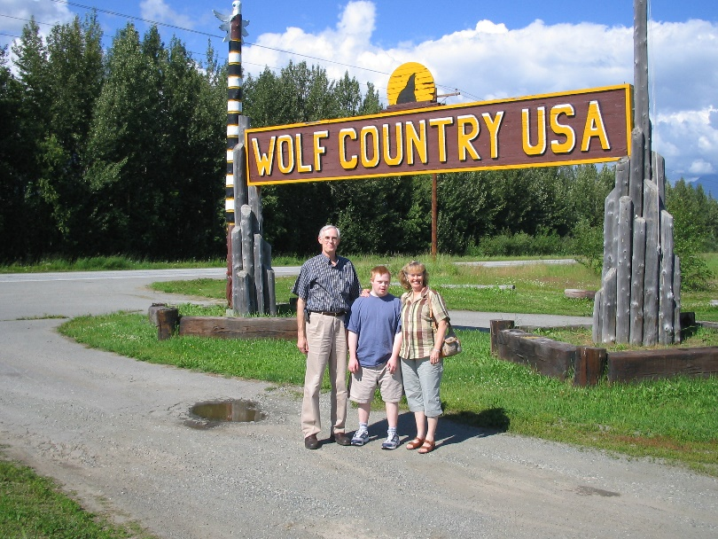**Anchorage Alaska to Terry & Angela’s in July 2005 –** I had never been up to Terry & Angela’s even though Ken and all my siblings had. Terry told us that and asked when we could come. It happened that we could go that year, so Ken said we better go. We got back from our mission in February 2005 and left for Anchorage in July. It was so beautiful and green.

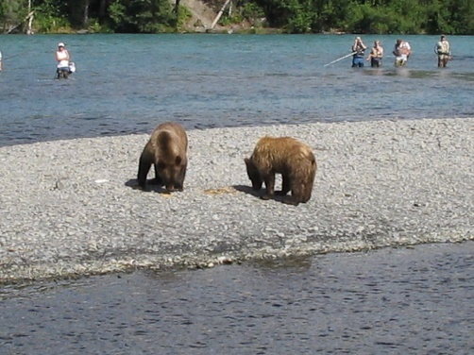Terry was so cute, he picked us up at the airport with Jaben and took us places on the way to his home. Angela had hurt her back and was in a lot of pain, so felt bad that she couldn’t go. Because of this, she couldn’t go the first few days as Terry took us to see the sights.

Ken wanted to go fishing, so David, Terry’s son, took him one day, but they didn’t catch anything which was unusual. They did see several bears in and around the river. He went another day with Jared, but again they didn’t catch anything.

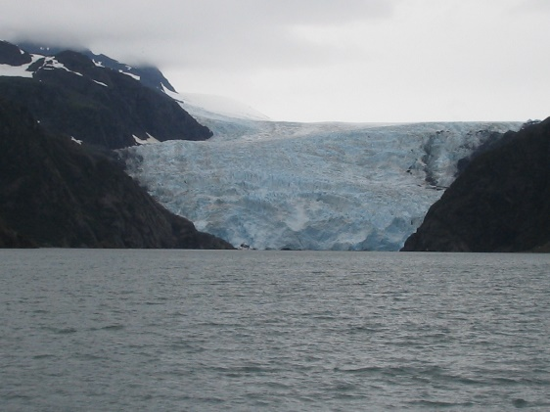Ken & I went on a day cruise, which was wonderful. We saw whales, sea lions and practically all ocean wildlife. The captain told us all about everything. We saw beautiful glaciers, had wonderful meals – everything was great.

Ken went with a friend, who we saw at church and who was visiting relatives, on a Halibut and Salmon boat and caught both. He had them quick frozen, packaged and sent home to us. It was quite expensive, but worth it – at least this once.

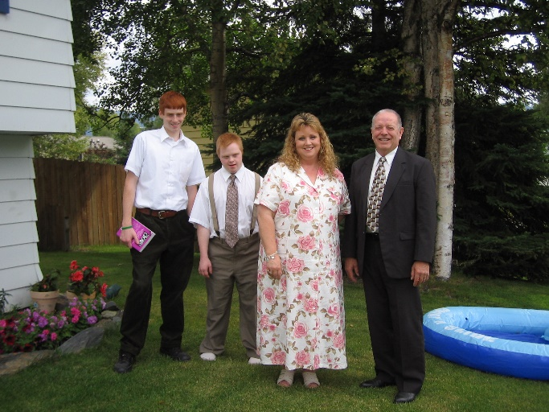Terry, Angela and their family took us to the ocean and park for a picnic, to their stake camp where we went canoeing on the lake, had a picnic, etc. Terry, Angela, Ken & I went on a session at the Anchorage Temple. Terry is a temple worker there and loves it.

I went with Angela and her two daughters-in-laws to a flea market where we had fun shopping. We played games at night, their son’s and families came over several times and we ate, visited and played games. We loved being with them and their special family.

Jaben was cute. He is “Down Syndrome”, can’t talk, so just make sounds, but holds out his hand to do a “high five”, shake hands or hold your hand. He is cute and affectionate. He was about 19 at this time. He is short and stocky, and a challenge for Terry, Angela and their family, but they all love him very much. Terry & Angela were great hosts and we had a fabulous two weeks with them.

**In October, 2005, Shellie and the boys came up in 2005 to visit and spend time with us and the rest of our family.** Roy couldn’t come as he needed to work.

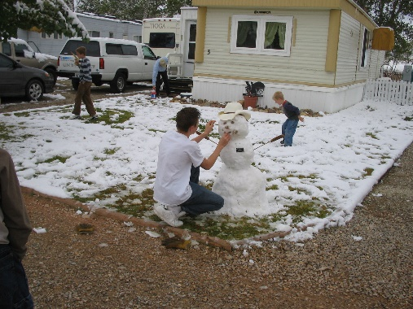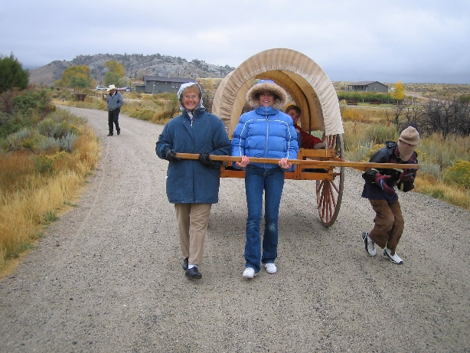Shellie wanted to take the boys and go to **“Martin’s Cove”** where Roy’s parents, Veldon & Patsy, were serving a six-month (summer) mission there. Shellie wondered if Ken and I could go with them, and we were excited to go. We stayed the night with Patsy & Veldon’s neighbor and Shellie and the boys stayed with Patsy & Veldon in their RV. They have to have RV’s to stay in with these service missions. We had a great time, although it was cold and windy. It snowed the one night, so the next morning the boys made a snowman and then most of us had a snowball fight. The visitors center was wonderful and **we saw my great grandfather, Lyman Wight’s name on the list of those who went to rescue the handcart saints, who were stranded here in Wyoming in the terrible cold, snow and wind of winter**. How any of them survived is a miracle.

They had handcarts there that we could pull each other in. Veldon took us in his outdoor vehicle to the spot that they call “Martin’s Cove” where the saints were trying to get by the hills to get out of the terrible cold. We saw many other sights there and enjoyed the time with Shellie and our grandsons. Also, with Patsy & Veldon, as they are good friends.

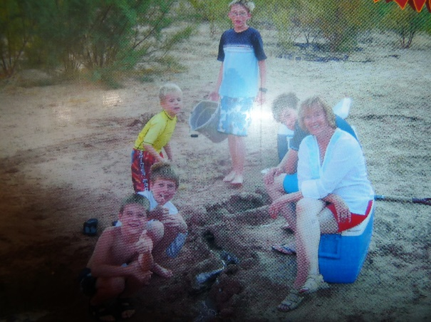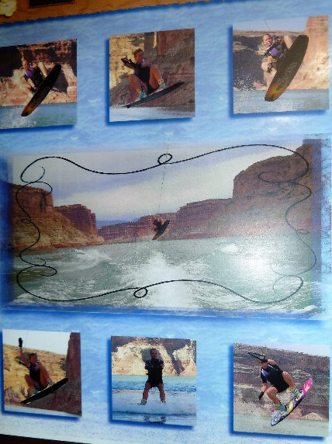**Vacation at Lake Powell with Shellie, Roy & Family.** We spent a week at Lake Powell the **summer of 2006** with our daughter, Shellie, her husband Roy and their four sons – Garrett, Quint, Kevis & Jase. We were on a house boat, we had our fishing boat and they had their ski boat. It was lots of fun. We took turns fixing the meals. It was hot so we were in the water a lot. I helped the boys make sand castles and rivers and motes around the castles, on the beach where we were docked. The older grandsons walked over to the other side of the cove and jumped off the rocks and cliffs into the water. They had a fun time, but I was glad when they were finished and came back safely. I’m sure Shellie was also. We played games whenever we were not in the boats, fixing meals or eating.

Ken and I had a great time fishing, one day, as the special kind of fish there, Silverfish?? were on the hook the minute it hit the water. We caught lots of fish and they were large. Many times, both of us would catch one at the same time. Our kids went in together and had bought Ken a beautiful new fishing pole & reel for his birthday that year. Ken laid it down to take a picture of me with my fish. When he went to pick up his pole, it was gone. A fish had bit at his hook and took off with his pole. He was sick about that. We tried to find it by using my pole, but couldn’t. The owner of the boat drove the house boat, and he was fun to be with too. He kept to himself a lot of the time so he wouldn’t intrude on our privacy.

Some years earlier, Shellie’s in-laws, Veldon & Patsy Seymore, some of Roy’s siblings and Shellie & Roy rented this same houseboat, and they invited our family. Sandi, JaNae & Chelci came with us and also our four sons. The Seymores had rented a paragliding outfit and they had a boat pulling them. They told any of our family to come and do it with them. I thought it would be fun, so when I got them, they hooked me up, the boat took off and away I went up into the clear blue yonder. It was so fun and as I looked all around me at the beautiful lake, other boats, and all that Lake Powell has, I was so thrilled. It was great being up in the sky, being held up by a parachute. I could see all over. Finally, the boat slowed down and stopped and I drifted down and lit in the water. It didn’t hurt and I was still kept afloat. The boat circled around and picked me up. What a great experience. I’m not sure how many of the others got to do that. Shellie went on it before I got there, but as the boat started moving, a wind picked up and threw Shellie on the rugged shore, drug her some and she got skinned up and didn’t have a fun experience. No one told me that, and Shellie was taken back to the houseboat to get fixed up, so I didn’t see her. If I had known that, I probably wouldn’t have had the nerve to do it. We all had a great time.

.

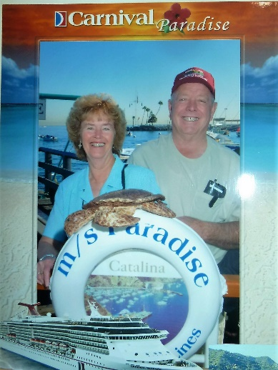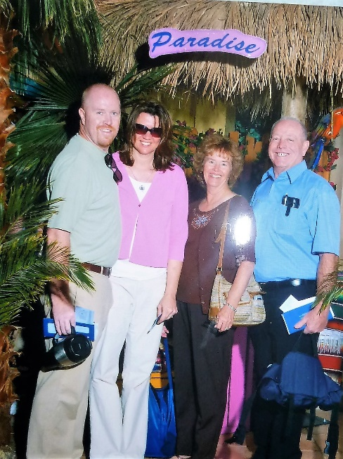 **Cruise with Mike & Becky in November of 2006** Our first cruise. Our oldest son, Mike and his wife, Becky, invited us to go with them on a Carnival cruise. It was out of Long Beach, California and stopped at the ports of Catalina and Ensenada. It was fun and we had an enjoyable time being with Mike and Becky. We drove down together and stayed at a motel in Los Angeles, and then a shuttle took us to the ship the next morning and came to get us when our ship landed and the cruse was over. Ken & I went on a Glass Bottom Boat tour in Catalina where you could see and feed beautiful fish. We also went on a city bus tour and stopped at interesting spots along the way. Mike & Becky went snorkeling. At Ensenada, we went to the Blow Hole where the ocean water blows up at various times. We walked through lots of sidewalk shops along the way. On the ship we swam in the pool and sunbathed, played games, ate lots of wonderful food, watched good entertainment at night, one was a magician. All in all, we had a grand, relaxing time.

**Zion Canyon – with Jeff, Gail & little Benjamin in October of 2006. Then Rachel & Matt were born and we continued to go - 2007, 2009 & 2013, etc.**

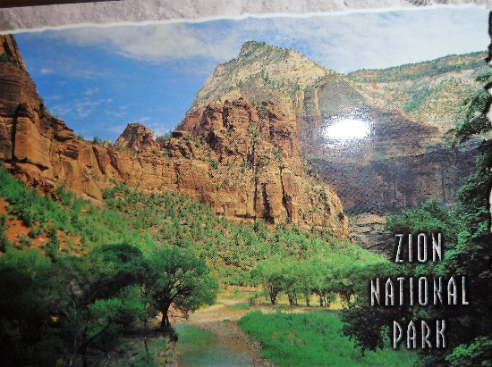

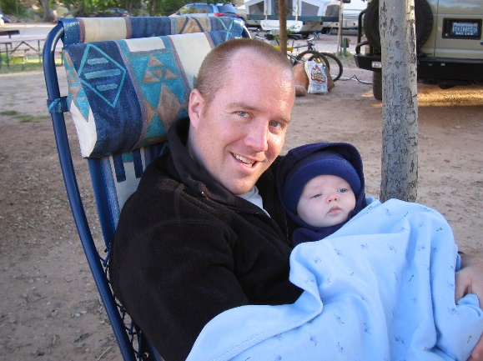Jeff and Gail wanted to go to Zion Canyon in October of **2006** and they asked if we would go with them. We had our tent trailer and it would easily fit all of us. We pulled the tent trailer with our truck so we were able to take their sleeping bags, portable crib & stroller for Ben. We had a great time and Benji was so cute and enjoyed being in the stroller as we went on the shuttle bus and walked the trails. We took lots of pictures and have 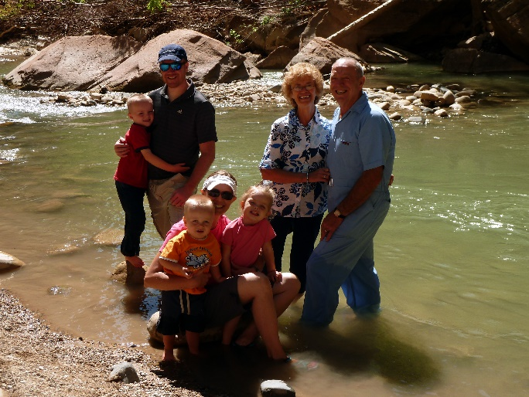done each time we went. This is Jeff’s favorite place and he has come with his brothers and cousins to explore canyons by climbing and repelling. They had great times here too. We ate together, played games at night after getting Ben to sleep and Ken and I tended Ben while Jeff & Gail climbed Angels’ Landing. It was beautiful there and we loved it.

We camped one year at the RV Park in Springdale because it had showers and we had a pretty site looking at the red mountains.

The other years we camped at Watchman campground at Zion’s. It has electric hookups, but no water or sewer hookups so we had to fill our water tank in our tent trailer as we entered the campground. It was fun each time we went and soon we had little Rachel and so they had a double stroller, then Ben was old enough to walk and Matt was born and he was in the stroller with Rachel. The last time in 2013, all the three children were able to walk and probably out hiked their grandmother and grandfather. We would tend the children while Jeff & Gail took the hike to Eagle’s Landing. I didn’t dare go there, but Ken went a couple of times, and really enjoyed it. One time he had been sick and I didn’t think he should go, but he wanted to and did just fine.

**Cedar Breaks – coming home from Zion’s in October of 2006 –** Ken and I decided to take a detour when we were coming home from camping with Jeff, Gail & little Ben for a week at Zion’s Canyon. We wanted to go through Cedar Breaks as we hadn’t been there for several years and it is so beautiful. We stopped at the different lookouts and enjoyed the beauty and took pictures.

This reminded me of several years ago when **dad** **wanted to go on a trip down to Southern Utah and see Zion’s Canyon, and other places for the last time**. His health had been declining as he had an inherited disease “Anti Tripson Deficiency” which is a lung disease. Mom had told me that he really hoped someone would take them there. I went into his office /bedroom where he was and told him that I was sure that Ken would agree that we could take he and mom on that trip. He got all excited and said they would pay for the gas. The next thing I knew was Mom calling me at home and saying: “Did you tell your dad that we were going this coming weekend?” I said “no” and she said well, he thinks you did and he’s getting packed to go. Ken and I didn’t want to disappoint him so we did make arrangements to take them.

We had a wonderful time. When we were at Zion’s, dad didn’t have the energy to walk on any of the trails, but they said for Ken and I to go and they would just wait there at the camp. As we were about to head for home, we asked if they would like to go see Cedar Breaks too and they said they would. Well, that was a mistake as it is too high and the altitude was too hard on dad. He couldn’t breathe well and so we quickly went on home. He kept declining until he had to be on oxygen 24/7. We felt bad that we had taken him up there.

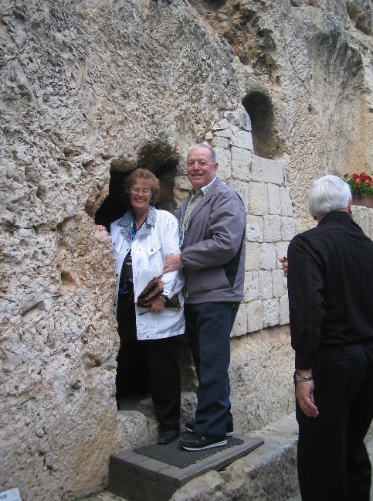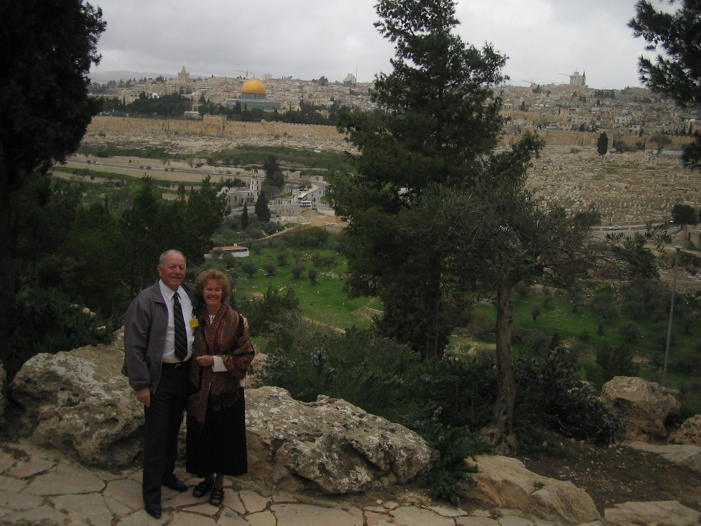**In March of 2007, we went on a tour to Israel with our daughter, Shellie, her husband, Roy, and 3 of their 4 sons.** **Roy’s parents went also.** Shellie had gone to Israel on the Travel Abroad Program with BYU when she was in college 20 years ago. It had always been her dream to return with her husband and children. This was the year. Shellie & Roy’s oldest son, Garrett, will be 19 and go on a mission next year, so they wanted to go now. They took Quint & Kevis too, but Jase was too young to go. They invited Ken & I and Roy’s parents also. It cost us $7,000. This was a hard decision to make as that is a lot of money and we are not wealthy by any means, but Shellie kept telling us that it was an experience that we would always remember and that we would be with them and probably never have the opportunity again if we didn’t go now. Most of the children were supportive, but David was not. He knew we didn’t have much money and thought it was foolish for us to spend that kind of money on a vacation. He even got angry and it was very upsetting to me, but we went, and he apologized later and we are glad we went. It was a glorious 14 days on a wonderful tour where everything was taken care of and we walked where the Savior walked and went inside the Dome of the Rock, Garden of Gethsemane – all the wonderful places in Jerusalem plus all over Israel – the Dead Sea, the River Jordan where Jesus was baptized by John the Baptist, the Sea of Galilee, the place where David slew Goliath, where Abraham, Isaac and Jacob were buried and King David, the walls of Jericho, the place where Sampson and Delilah were, etc. We ate foods we have never heard of before, we had great hotels we stayed in. Our tour guide was excellent and we enjoyed every minute of it. There were 34 on our tour.  There were 3 former mission presidents with their wives, Brother Robert Whetton, who was recently released from the Seventy, and his wife, and other former bishops and stake presidents and their wives - so we were with a great group.  Our guide, Brother Richard Barrett, had just retired from 40 years of teaching institute.  He had taken 26 tours over to the Holy Land and he had taught 3 years and been in the Administration of the Jerusalem Center - so he was so knowledgeable and we learned so much from him.

It was great being with our special, beautiful daughter, her handsome husband and handsome sons and Roy’s parents, Veldon & Patsy. This was in March of 2007. Upon our return, Shellie took hers and our pictures and put them together and made a scrapbook for us for Christmas. We love it.

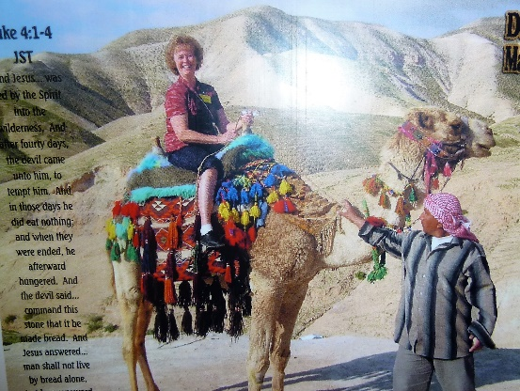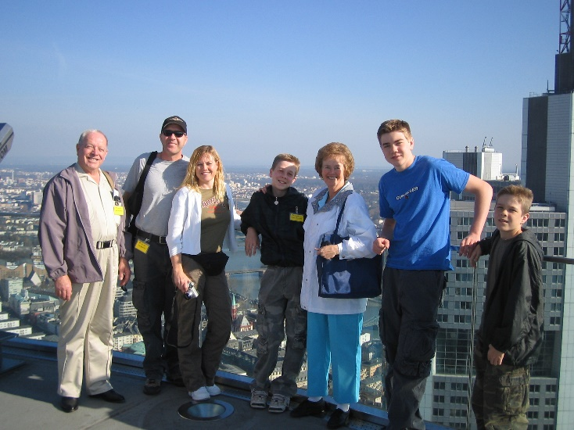**Short summery of trip to Israel with Shellie, Roy & sons in 2007**. (2nd writing of this wonderful trip, so wanted to include it also.) Ken and I returned from Israel late on the 29th, so we still had jet lag.  We sure had a marvelous time in Israel.  It was incredible.  It's more beautiful than we had imagined, and is such an interesting place.  Our guide was great, so we learned a lot.  It was wonderful to walk where Jesus walked, to be at the place when David slew Goliath, to be at Mt. Carmel where Elisha challenged the priests of Baal to see which God would burn their sacrifice, to be in Jericho and hear those stories we have heard since a youth, but they meant so much more since we were there.  I was able to ride a camel, which was a fun experience. We rode a gondola up to Masada and our guide showed us around and told us all that went on there - much more than we had heard before.  We swam in the Sea of Galilee and rode in a boat (like the boat Jesus and his disciples would have been in) over to Capernaum.  We watched people being baptized in the Jordan River where John the Baptist had baptized people.  We floated in the Dead Sea, and saw the caves where they found the Dead Sea Scrolls.  We saw King David's tomb.  We were at the place where Abraham rescued Lot from the kings.  We were in Hebron and at the sites where Abraham, Isaac, and Jacob were buried with their wives, except Rachel who was buried in Bethlehem.  We were in Nazareth & Bethlehem.  We were in Bethany where Mary, Martha and Lazareth lived and visited the tomb where Lazareth was raised from the dead.  We spent a week in Jerusalem and that was fantastic.  Besides visiting all the places where Jesus walked and going to the Jerusalem Center for church and a tour, we bought lots of souvenirs in the old city as well as other places.  It was amazing to see all the ruins and to realize that

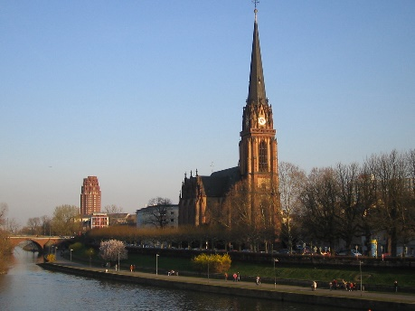several civilizations had built their cities on top of others which had been destroyed.  I could go on and go.  We are so glad we went.  Before going on to Israel, we had a layover in **Frankford, Germany** for an entire day, so the Barrett’s, our tour guides, had hired a German lady tour guide to show us around. One of the highlights was to see and walk around the beautiful Frankford Temple. We also ate good food. We were glad that we had this opportunity to be in Germany also. The picture above shows some of the architectural and scenic beauty.

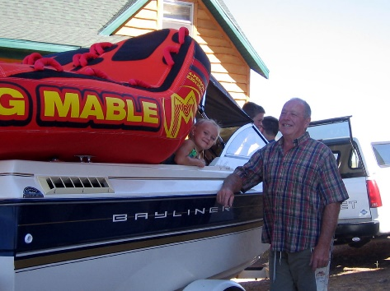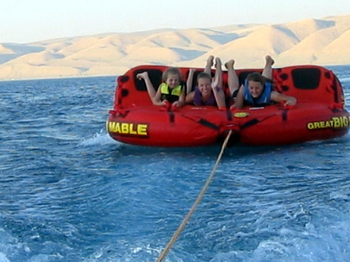**We had a wonderful family vacation at Bear Lake with all our children and their families (34 out of 36) in July.** We rented a large cabin and had a great time boating, fishing, wakeboarding, riding on the toys, swimming, playing on the beach, eating, visiting, playing games and just relaxing and enjoying being together. These pictures are of our family and Ken, on or by, our big water toy “Great Big Mable”. Ken had told me to go to Petersen Marine and buy a water toy and make sure it was a good one and big enough. The salesman sold me this one, and it was too big for our boat, but we had fun on it anyway.

David & Shauna brought their boat, so we all had a great time, fishing, water skiing or playing on Big Mable & other water toys. We rented a large home there with several bedrooms and hide-a-beds. It was a fun place. We took turns fixing the meals and we played games and did lots of visiting. It seems like all of our family were there. It was fun watching our grandchildren having so much fun. Chelci is pregnant and had kidney stones and was really miserable for part of the time. She finally passed them. Gail and JaNae both announced to all of us that they were pregnant. Mishelle was happy for them, but it made her sad as she wants another baby so badly. She got pregnant soon after and they now have twins, a boy, Kaden, and a girl, Kaitlyn.

**Heber Valley Railroad and play with part of family (Jeff & Gail, Sandi & Nick, Chelci & Steve) in Sept 2007.** Gail, Jeff & family wanted to go on the Heber Valley Creeper and asked us and the rest of the family if they would like to go with them. Several of us went and had a great time. I have always heard about this train and wanted to go on it too. They had a short play and the tickets came with dinner. They served pizza and pop. It was fun.

**We went to Zion’s National Park again this year in October**. When we came, Ben was able to walk around, but we didn’t want him getting away from us and out in the roads so we used our vehicles to enclose him in. He played with sand toys and dirt for hours. He didn’t stay clean, of course, but he had so much fun. We visited and played games while he played. We loved going on the trails and shuttle bus again. Ken and I love it here too.

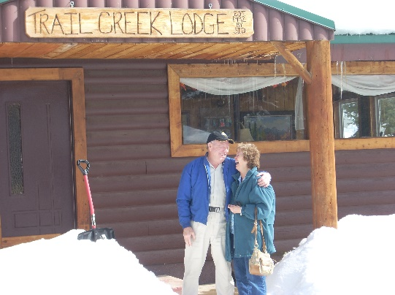**We enjoy being with our special family and were able to have several snowmobiling, fishing and camping trips this year with them and lots of family dinners and activities. I wrote up our Snowmobiling trip with Sandi & Nick at the Trail Canyon Lodge for Ken’s birthday 2008. His birthday is the 27th of February.**

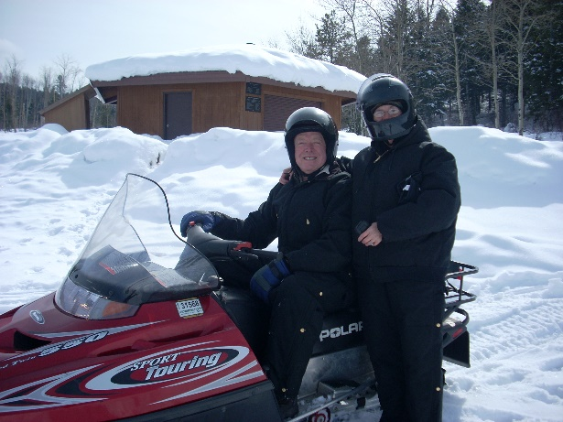Ken wanted to celebrate his birthday at Lava and soak in the mineral tubs.  He also wanted to go snowmobiling so he checked around and found the best place to do that was at Soda Springs in Idaho which is just 25 miles from Lava.  Sandi and Nick went with us and we had a great time.  We spent one night at Lava and one night at Soda Springs.  The lodge was so fun there at Soda Springs.  It is a bed and breakfast.  We were the only ones there at that time, so it was really fun.  The owner gave us a super deal since we were renting a double snowmobile for $120.00 and since we weren't there on a weekend.  He gave us 2 rooms for $40.00 ($20.00 for each couple) and that included a wonderful breakfast of sausage, eggs, hash browns, toast and orange juice.  The lodge had a large screen TV with a DVD player, hot tub, fireplace, tables to play games, etc. plus 25 miles of groomed snow mobile trails with lots of hills and valleys to play around on.  The four of us plan to go again next year, and we'd like to invite any of the rest of you to go with us.  We will stay the two nights at the Lodge in Soda Springs rather than stay one night in Lava.  They have several snowmobiles to rent.  If you rent a snowmobile, they furnish the snowmobile outfits free.   We had all of that for Wednesday afternoon, Wednesday night and most of the day on Thursday.   It only cost us $76.00 a couple, (we shared the cost of the snowmobile and the rooms).   Sandi said it was the most fun she has ever had snowmobiling.  This was the first time Nick has been snowmobiling and I asked him if he liked it and he said he loved it.  We all did.

**Ken and I went to Payson Lake to camp for a few days before going on down to Zion Canyon where we would meet up with Jeff, Gail and family the last of September.** We were not at Payson Lake very long before the camp host came over and said they got a report that a bad snow storm on was its way and that they were to close the camp and get down off the mountain. They said since we had already paid, we could stay if we wanted to, but we might be stranded up there for a while. We didn’t dare chance it, so we left and it started snowing as we went down the canyon so we were glad we had gone. It snowed or rained most of the way to Fillmore so we decided to stay in a motel there rather than in a KOA.

We had a wonderful time 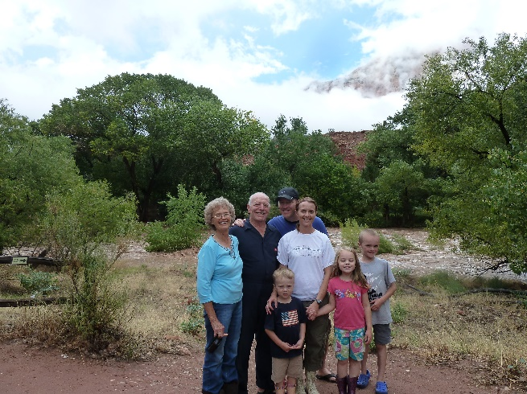with Jeff, Gail, Benjamin & baby Rachel at Zion’s. In our tent trailer, there was room for all of us. They put Rachel in their little folding bed. They have a double stroller, so away we would go during the day to enjoy the beautiful Zion’s National Park. We were able to fold up the stroller and with the help of all of us; we could get the stroller and children into the shuttle bus and get off at the different sights or hikes. We would put the children to bed at night and play games. The four of us love playing games and coming to Zion’s.

**This picture is of a later trip to Zion’s with Jeff, Gail & family as of this trip, they only had Ben & Rachel and they were little.**

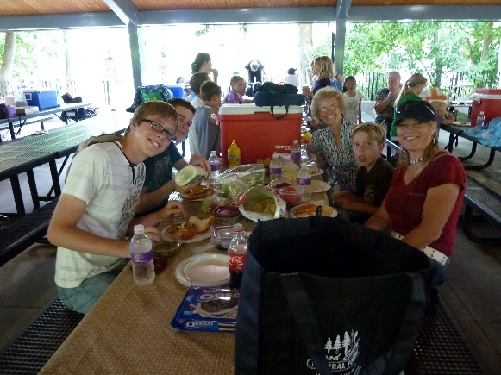 **Shellie & her family come up each summer and we always have a great time**. Her siblings and their families join in on the activities and trips. We usually always have a family barbecue at our home. One time we had a family breakfast of biscuits, gravy, bacon & eggs, in our back yard. It had been a tradition to have Ken make biscuits & gravy for our family. Everyone loves them.

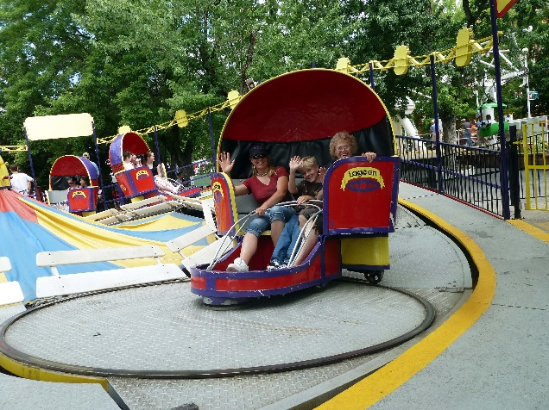We also go to **Lagoon** for one day and sometimes get the “bounce back” ticket and go back the next day. I have gone with them most years and love being with this special family and having fun with them on the rides, and enjoying the beauty of the flower gardens and trees that are there. Ken doesn’t love Lagoon, but sometimes would come in the evening to have the picnic dinner with us and then walk around pioneer village, have an ice cream cone and then go watch the good entertainment that was there at that time. Ken and I love having Shellie & her family here with us, but sometimes they go stay with her siblings for a day or two also.

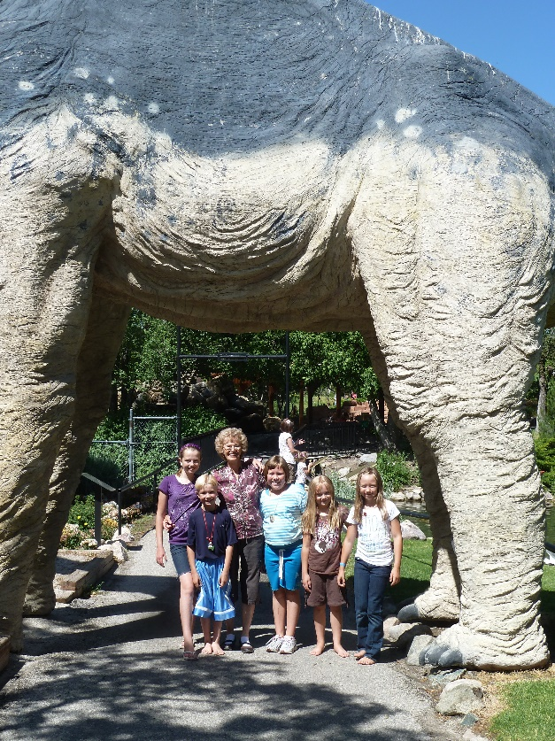 **For several years I have purchased a Grandmother’s yearly pass to Dinosaur Park in Ogden and enjoy taking the grandchildren there throughout the year.**

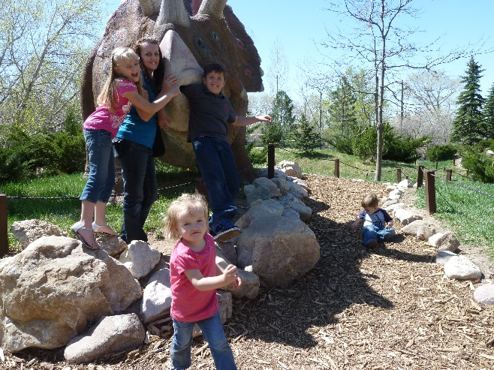 I started doing this when David and Taylor Paige were young. They were about 7 and 9 years old, I think. I took all the grandkids there usually at least once or twice a year. I usually just took one family’s children at a time, but as they got older, sometimes I would take cousins. In our Buicks, I could take 5 grandkids, but now in our Chev Impala, I can only take four. Most of these grandchildren love to go there, even when they are teenagers. I mentioned that to Shauna, one day, and she said it was mainly because they wanted to spend time with Grandma. Her comment made my day. I love to be with our children too. Ken went a couple of times with us, but he was usually working or doing projects for us or other family or friends. Dinosaur Park is a fun place, especially for younger children. They have a great museum where all kinds of Dinosaur skeletons are displays on the main floor and upstairs, they have displays of all different kinds of rocks made into jewelry or other items. They also have an area upstairs where they have robot dinosaurs that growl and move somewhat. The children love this area. Outside is lots of paths which take you to different full-size manmade dinosaurs, they growl too. They also have a playground made up of manmade dinosaurs, etc. They have an area where you can dig for bones – actually use brushes to uncover dinosaur bones and eggs. Another area is where you overlook the pond and can buy food to feed the large fish, ducks & geese. They have other hidden paths, etc., etc. It is a fun place. I don’t know how many times I have been there, but it is still fun, especially to watch the grandchildren having such a good time. We usually take our lunch and treats as there are picnic areas all around. They also have a gift shop and snack bar. The gifts are too expensive, but I usually buy the grandchildren an ice cream treat, just before leaving to go home.

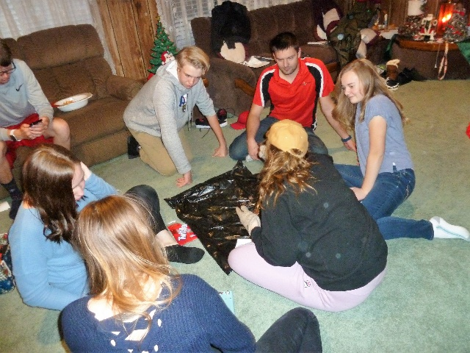We always have a **family Christmas party**, but last year we also had our first **“Grandchildren’s Christmas party**”. I got the idea from Sister Hinckley’s book about her life 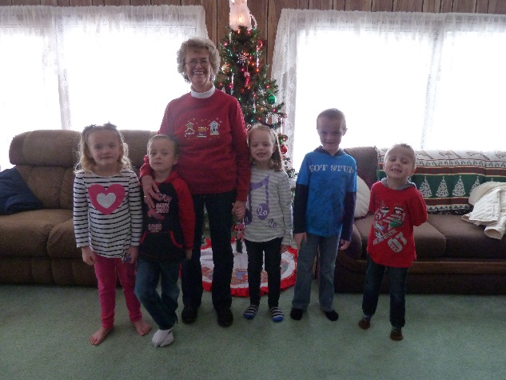(can’t remember the name of the book). I liked this idea so decided to try it. The first year I also invited our great grandchildren (Dawson, Kennedy, Emma, Jaden and Nathan). This was almost too many for me to handle, but I had Paige help me. To this day 2019, I am still having these grandchildren Christmas parties, although I have two – the older children and the younger children’s Christmas party. I used to have the younger one in the morning and the older one in the afternoon, but now I have one on one day and the other are another day. The younger one I still have in the morning and the older one in the evening. The problem now is that many of the older grandchildren have graduated from high school and some are married. JaNae & Chelci were already married with children, when I started these. This next year, 2020, Maddy & Ashley will also graduate, and once they all graduate, they have jobs, go to college, etc. The only ones still in high school will be Jessie and Connor. This past December, they all came, even Tyler and Emily, who are in college. Ben is 13 now and all these younger grandchildren are growing up, so the games and activities we used to do have been changing to the games I used to do with the older grandchildren.

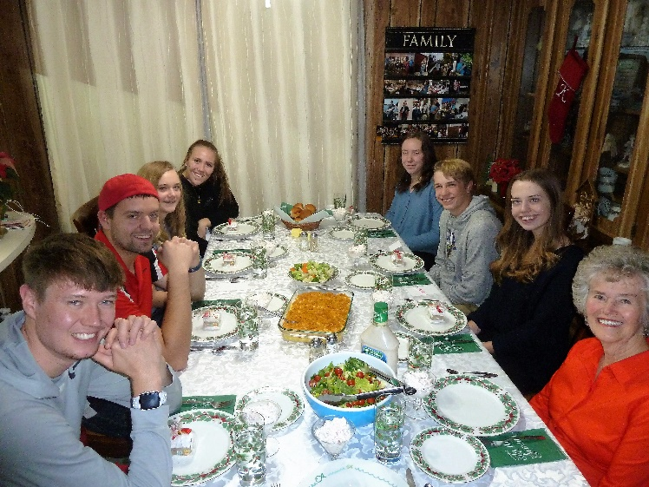Actually, with the older grandchildren, I prepare a good dinner and then we play parlor games, card and board games and visit. I have had different ideas over the past, for the older grandchildren. One year we ate dinner and then went to an Assisted Living Center in Clinton and put on the program for these senior citizens. Emily plays the violin so beautifully, so she played a couple of numbers, Kylan plays the piano and is excellent – he plays by ear, so he played a couple of numbers. All of us sang Christmas carols to them, and they all enjoyed our program. Another year, after eating, we took treats to our aged neighbors, and sang Christmas carols to them. One year I prepared several “Minit-to Winit” games and that was fun. This picture was last December 2018.

With the younger grandchildren, we usually have a treasure hunt, a fish pond, and lots of other fun relays or games. I have prizes for the winners, but I make sure they all get the same number of gifts.

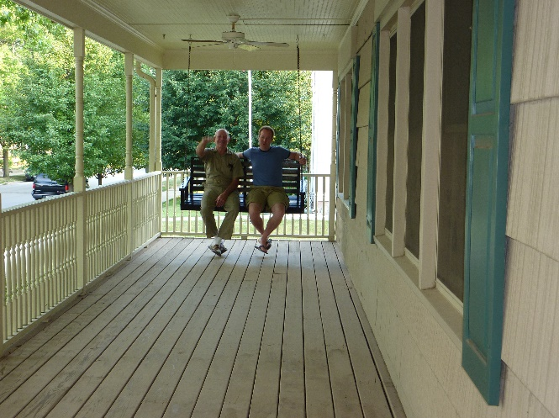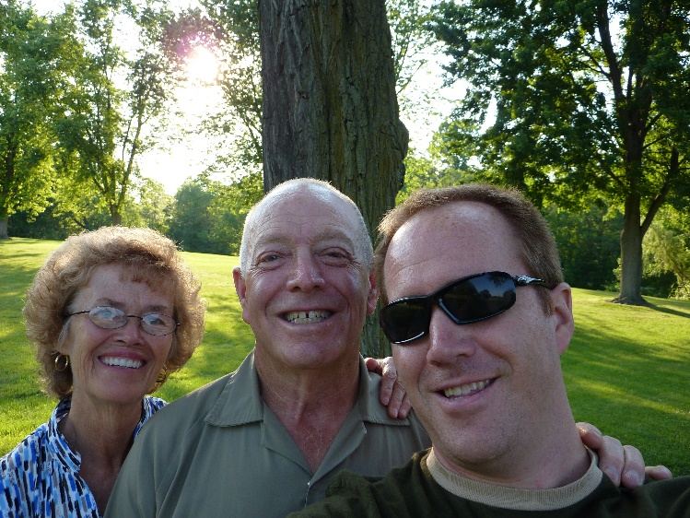**Vacation to be with Jeff in Greenville Ohio, Nauvoo, Illinois and Kirkland, Ohio in July of 2008.** Jeff had transferred with his job to Greenville, Ohio when he and Gail separated. Ken and I wanted to go visit him there and he wanted us to come so we went in July of 2009. We have always wanted to go to the church history sites back there – Nauvoo, Illinois and Kirkland, Ohio so we talked to Jeff about it and he said we could use his car and he would just ride his bike back and forth to work. We flew into Cincinnati and Jeff met us at the airport and took us to his home that he was renting. It was an old home, but cute as it had a wrap-around porch with a swing. He had the upstairs apartment which consisted of a living room, kitchen, two-bedroom, bath and a screened in porch. We enjoyed being there and spending time with Jeff. On the weekends, he would take us sightseeing. It is beautiful there with beautiful trees everywhere. It is so lush and green. They don’t irrigate as they get plenty of rainfall. He took us to beautiful parks, one in particular I loved as you would walk down paths to a lake with trees, shrubs and flowers everywhere. It was more a wilderness park. He took us to the Annie Oakley Park where they tell all about her and have statues, etc. He took us out to eat at one of his favorite restaurants which was in a great area with trees, etc., all around. Ken and I went to Sacrament Meeting at the branch there both Sundays. I fixed our meals and it was fun to cook in his cute kitchen.

We arrived on Friday and on Monday Ken and I left for Nauvoo. Jeff let us use his car. We had made 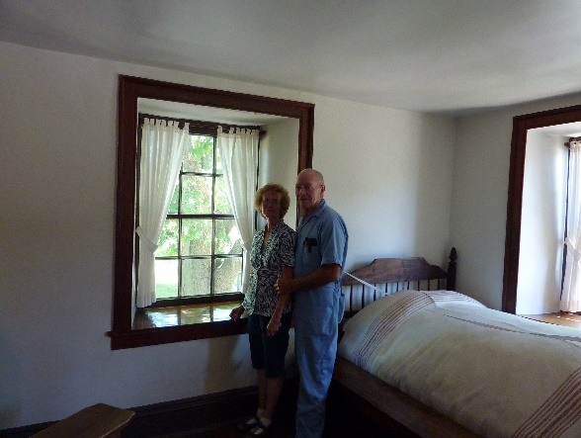reservations at a cute motel in a nearby town as it was much cheaper than staying in Nauvoo. We loved Nauvoo. It was beautiful and there was so much to see and do. Nothing cost money there, except for your meals. We went on a buggy ride all around the city where a tour guide told us all about everything in the city. It was great! We went on a covered wagon ride pulled by oxen and were told about the pioneers and the oxen. We walked down Parley Street or later it was called “The Street of Tears” as that is where the Saints went as they were driven out of their beautiful city in the dead of winter and had to cross the frozen river. They had to leave their beautiful homes and farms and their beautiful temple which they had sacrificed so greatly to build and worked on it even knowing they would be leaving it to mobs. Many did get their endowments there before they left as Brigham Young & other members of the twelve stayed night and day to give these ordinances to the members. Ken and I went in museums and all the homes where there were couple missionaries there to take us on tours of the homes and in some they would demonstrate how they made rope, wax candles, spoon cotton into yarn, silk worms, etc. The mansion house was one of the homes we toured, plus we toured the shops, and other businesses. We also went to the Nauvoo temple one day. You had to get reservations way ahead to do this and so we had done that before we left home. We ate in fun restaurants and cafes. The night programs were excellent – talent shows and plays. The couple missionaries and young missionaries put these on and they were wonderful, so talented. We missed the pageant by a couple of weeks, but most people want to come at that time, so it wasn’t so crowded and that was great! We enjoyed our motel and going back and forth across the Missouri River and one day we watched the huge gates come up and open so boats and ships could pass through. That was interesting. Anyway, Ken and I had a wonderful five days in Nauvoo and we still didn’t see and do everything, but we 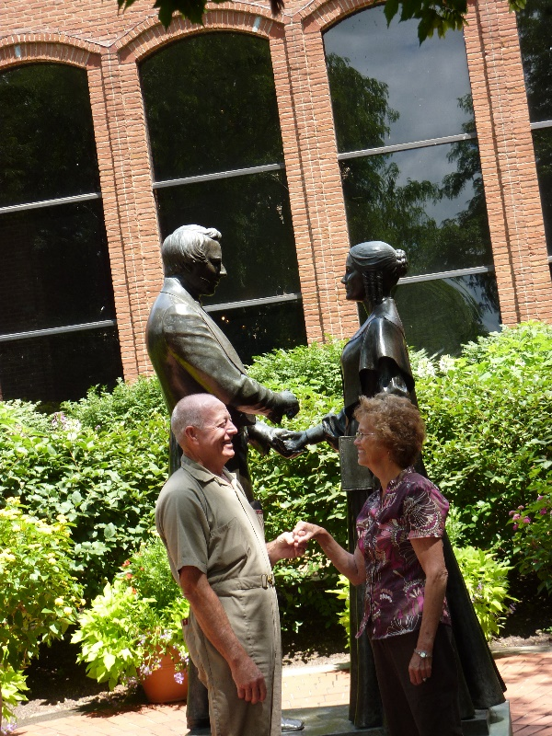did see a lot and loved it.

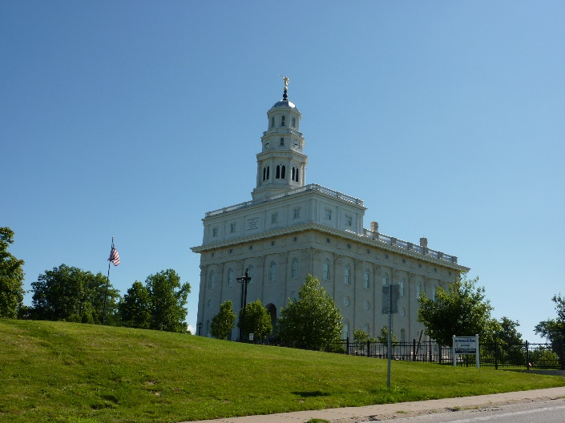 The following Monday, we left for Kirtland to see the church history sites there. We had already made reservations at a nice hotel there. We had phoned Maryon and Jim Frazier, our good friends from when we lived in Arizona and who had moved to Springville, Ohio, which isn’t far from Greenville. They were planning to go to Kirtland with us, but things came up and they weren’t able to, so we went to visit them at their home. They have a beautiful farm on top of a hill. There are lots of trees until you get to the top. They have an old home, but it was still nice. Ken and I didn’t recognize Jim & Maryon. They were sitting outside on their chairs waiting for us, but when we saw them, we thought we must be at the wrong place so Ken went to ask them where the Fraziers lived. As he approached them, he finally recognized them as they called his name and walked out to greet us. Maryon has put on a lot of weight and of course, has gray hair now and Jim has put on weight and is bald. Their daughter, Malinda, and her four children are living with them because Malinda’s husband is in prison for sexually abusing their children. She has divorced him, of course. They are practically raising their adopted daughter’s daughter also as Pamela and her husband work and they have Jim and Maryon tend their daughter and just don’t come to get her after work. Sometimes it is several days or weeks before they come to see her or get her. Wow! I don’t get why Jim & Maryon are doing this. Anyway, we enjoyed being with them for most of a day and they took us to different points of interest in Springfield. Ken and I toured some of the church history homes and sites in and around Kirtland, including the Kirtland Temple. I was excited to see it and walk through it. It is owned by the Reorganized Church, but was great to see it. One day we went to see Lake Erie and it was beautiful, it is so huge that it looked like the ocean. It had large waves come in onto the beach. This was a wonderful vacation and we loved being with our son as we have surely missed him.

**Shellie came up to Utah**. She comes every summer. She usually brings her sons. We go to Lagoon one or two days, have family barbecues, family vacations and she visits her siblings also.

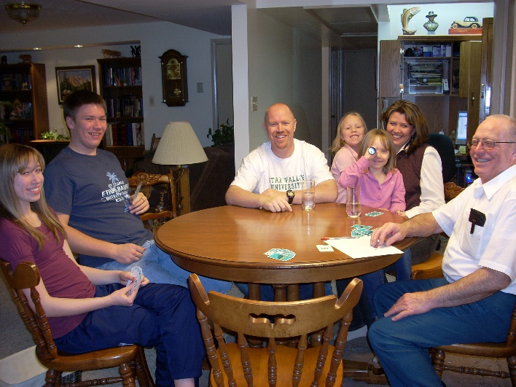

**Family dinners**

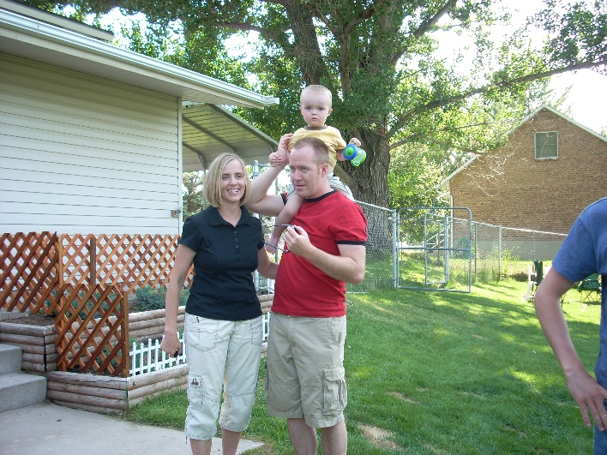We have a large back yard, but we have a small home. We have a living room, sun room, nice kitchen and 3 bedrooms, but only one bathroom. We can’t hold more than one family, during the winter, when we have family dinners, but that’s okay as we get more time with that family. Once in a while, we invite two families but then we are crowded. We love our family and love to be together as often as we can. Here is a picture of Mike & Becky’s family when they came. We usually play games after dinner. From left to right is: Paige, David, Mike, Maddy, Becky holding Jessie and Ken. I’m taking the picture.

The other picture is of Jeff, Gail & little Ben at one of our family barbecues in 2008. Boy, we surely have to enjoy these grandchildren while we can, as they grow up so fast.

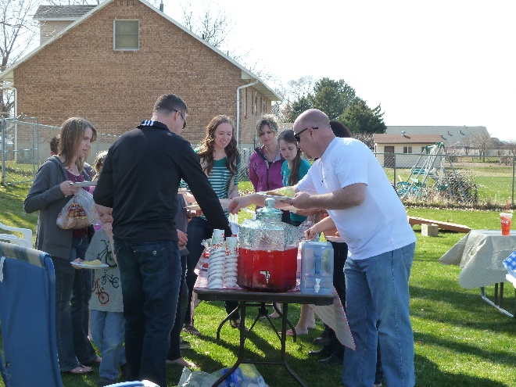**While living in Clinton**, in the basement apartment of Bob & Carroll’s home, which Ken built for their mother, we had a hugh back yard. When Mark moved to Provo, he didn’t take his volleyball poles, so Ken put the fittings in the ground so we could just slip the poles into them when our family would come for **family backyard parties and barbecues.** We had several each summer. Our children and grandchildren love to play volleyball so we played that at each family party. I love to watch them play. Each family would bring their own meat and a side dish. I usually asked Becky if she could bring her delicious broccoli and bacon salad as I love that and everyone else does also. Mishelle makes wonderful rolls, so she would bring rolls at times. All our daughters and daughters-in-laws make delicious food. I usually made a potato salad and an Acini de pepe salad. We bought two “Lifetime” picnic tables, from a neighbor who worked at “Lifetime” in Layton, and we have surely used them a lot and enjoyed them. We also bought two smaller picnic tables so our young grandchildren could sit at them. Our apartment wasn’t large enough to have all our family inside at one time, but in the summer, it worked great. In the winter, we would invite one or maybe two families at a time for Sunday dinner or for special occasions.

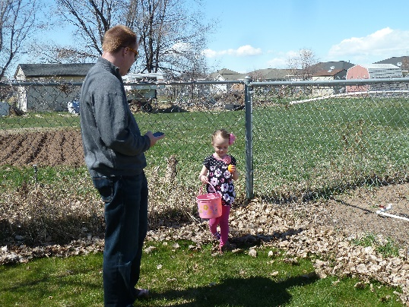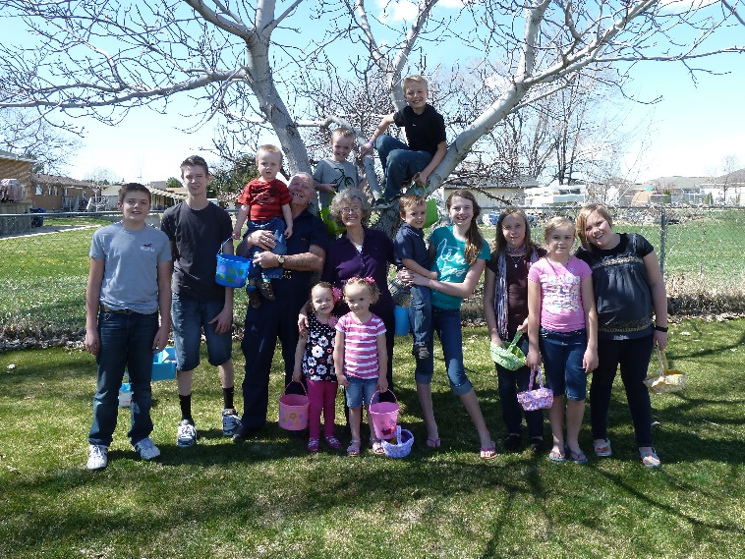We also had **Easter Egg Hunts** each year in our backyard. Those were fun. I would buy lots of plastic Easter eggs and put candy in some and money in some. I would color lots of boiled eggs also. Sometimes some of our younger grandchildren would come and help me color the eggs. Ken and I would hide the younger grandchildren’s eggs in the back yard and the older grandchildren’s eggs in the far back of the property where we had our chicken coop, shed, rabbit pens and large garden area. I bought Easter baskets for them at the Dollar Store and gave them a list of how many money eggs, candy eggs and boiled eggs each of them could find and keep. On the signal they would all run around to find their eggs, it was so fun watching them and seeing the excitement on their faces. We would usually start the Easter Egg Hunt about 10 am and then we would have a barbecue afterward, play volleyball and visit. Good memories!

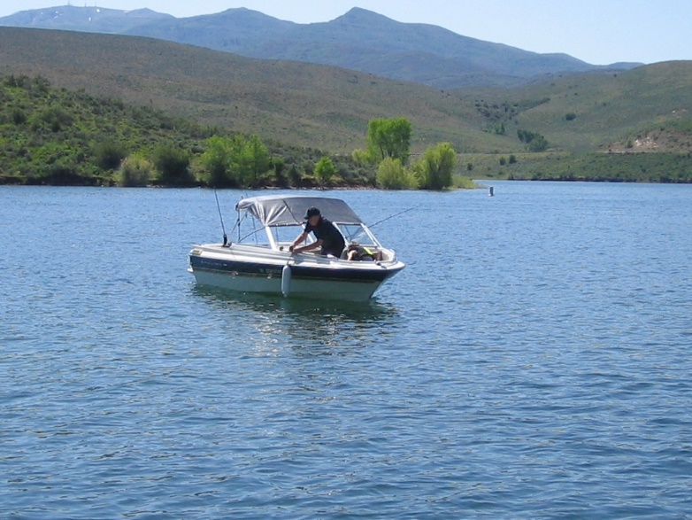**Fish Lake with Nick in August of 2009** Nick was the one to tell us about Fish Lake and how beautiful it is and what great fishing. He and Sandi hadn’t been married long when he suggested we go there together as he loves to fish like Ken does. It turned out that Chelci had her baby early (Nathan) and so Sandi needed to be with Chelci and help her and the baby, but Nick went with us anyway and we got to know him better this way. He pulled our tent trailer and we pulled our boat. He helped us with everything and we had a great time fishing and caught lots of fish, he likes to play games too so we played games at night. We were glad he went with us and we had a great time, although it would have even been better if Sandi could have come. We have gone several years there together and loved it.

**We went to Zion’s National Park with Jeff, Gail & family again this year**. They love it here and so do we. Jeff & Gail had added a daughter and another son to their family. Rachel was born in February 2008 and Matt was born in July of 2009 so in October of 2009, we still have room for all of us in our tent trailer as Ben & Rachel could sleep on the bed when the table usually goes and we put up the portable crib for Matt. We loved it again this year and the children were great! Jeff & Gail took a double stroller and Rachel and Matt rode in it and Ben was old enough to walk on his own. With the four adults, we could manage the stroller and children on the shuttle buses and the trails. The four of us played games after getting the children to sleep on our beds and afterwards transferring them to their beds. **We didn’t go in 2010** as Ken and I were on our mission to California

**One of our vacations was with Shellie, Roy & 3 sons, Quint, Kevis & Jase. Sandi & Dawson, Scott, Mishelle & family and Jeff, Gail & family in 2011.**

**This is the Schedule of Shellie, Roy and sons Road Trip vacation in July of 2011**

July 1 (Friday) Leave home & drive to & see the Grand Canyon then continue on to Zion's & camp there.

July 2 (Sat) See some of Zion's Canyon, go to Cove Fort & tour it, then on to the SL valley where we'll spend the night @ Jeff's home.

July 3 (Sun) Go to church w/ Gail & the kids then spend the day with Jeff & Gail playing games. Go to Sandi's & spend the night w/ her.

July 4 (Mon) Celebrate Independence Day in Grantsville as they have a parade & great activities all day ending with fireworks. Mom & Dad will join us & after the fireworks we'll go spend the night @ their home.

July 5 (Tues) Go fishing with Dad B.

July 6 (Wed) Spend day @ Lagoon.

July 7 (Thurs) Drive to Lava Hot Springs & play in water there. Drive on & camp @ Island Park, ID.

July 8 (Fri) Tour Island Park & West Yellowstone then drive on & stop @ the Lewis & Clark Caverns & tour them, then travel on to Glacier & camp for the night (LONG DAY).

July 9 (Sat) Drive through seeing Glacier & go into Canada then spend night in Glacier again.

July 10 (Sun) Drive to Yellowstone & stay there.

July 11 (Mon) See Yellowstone & go on to Cody. Stay with Mom & Dad S. if available? Go to rodeo?

July 12 (Tues) See Cody & murals? Go on to Grand Tetons Nat. Park & Jackson Hole then stay in Star Valley.

July 13 (Wed) Drive to Flaming Gorge & play in water & camp.

July 14 (Thurs) Drive to Durango, CO & camp nearby.

July 15 (Fri) Spend day in Durango (maybe go on train ride) then drive to & camp @ Mesa Verde.

July 16 (Sat) See Mesa Verde & camp there again.

July 17 (Sun) Stop @ Four Corners for picture & drive home!

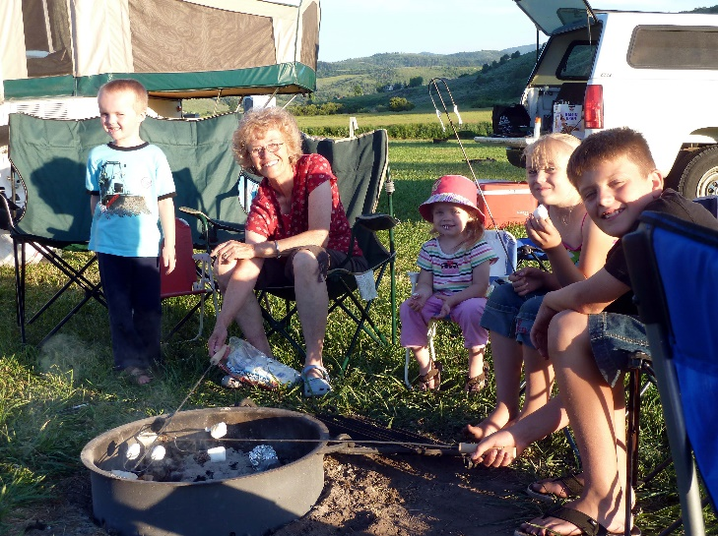Ken and I were with them most of this time except we stayed longer at Lava Hot Springs as Scott, Mishelle & family and Jeff, Gail & family were coming up and we wanted to spend time with them also. Scott & Mishelle & family were there when Shellie, Roy & sons and Sandi & Dawson were there so we all went rafting down the river a few times. It was fun. We also went to the mineral hot pools in Lava for one evening and we all enjoyed that. Jeff & Gail came the next day after Shellie & family and Sandi & Dawson had left. We all enjoyed being together. We ate together, played games, visited and played on the teeter totters which were in the campsites. After Scott, Jeff and families left to go home,

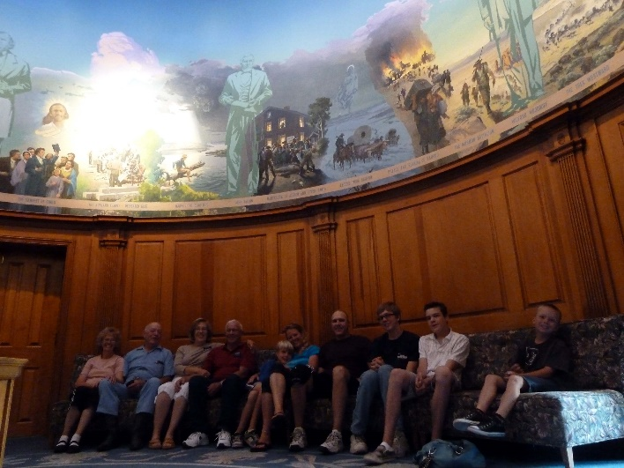Ken and I drove on up to Cody Wyoming to join up with our daughters and families. Roy’s parent’s, Veldon & Patsy, were on a mission there so we stayed with them and spent the following day with them showing us around Cody. We went to the church, where they serve, as it is also a museum and they took us on a tour of it. They then took us to the Buffalo Bill Cody museum and it was a fun place. They even had lots of guns and other memorabilia from Jonathon and John Browning. They had a Wild West show enactment on the streets in the evening. It was ok, but we saw much better ones at Old Tucson, Arizona when we went there, while living in Arizona.

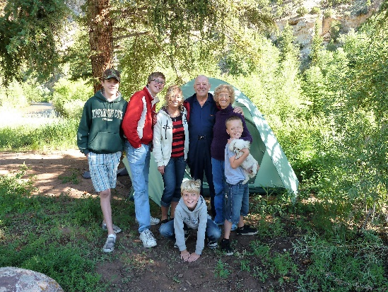 The next day we left Veldon & Patsy and drove on to Jackson Wyoming and spent the night there in a great motel. We all ate dinner at a cute café and then Ken and the boys went back to the motel and went swimming and in the hot tub. Ken’s feet were hurting so he didn’t feel like walking longer, but Shellie, Roy, Sandi and I walked down town and into the shops. Sandi, Shellie & I bought a T shirt and we had fun being together. The next morning, we ate at a nice café and had a good breakfast, then went on our way to **Flaming Gorge**. We set up camp and then let everyone take our boat and go boating while Ken and I fixed a Dutch Oven Dinner for all of us. They didn’t stay very long as it started to rain. We enjoyed visiting and singing around the campfire that night.

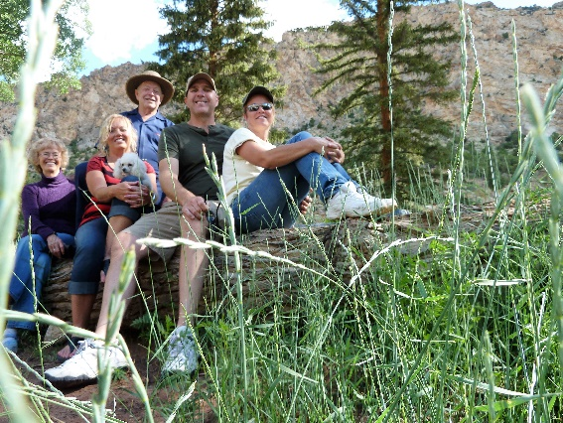After breakfast and pictures the next morning, all of them left us to go on their way to Durango Colorado where they spent another couple of days. Then they separated, and Sandi and Dawson left them and came back home and Shellie, Roy and boys went on to their home in Arizona. Ken and I wanted to stay longer at Flaming Gorge, so we enjoyed camping there for a couple more days. Ken caught fish in the stream by where we camped, and we took the boat and went fishing in the Gorge. We had a great time.

**Another vacation was going to Zion’s National Park again this year (2011) with Jeff, Gail & kids,** we went in September instead of October and it was way hot. We had to go on the trails during the morning hours and then play in the river in the afternoons. We were glad we had the river close by. One of the things I remember about this trip was when all of us hiked up the mountain trail on the other side of the tunnel, we met three oriental men. Don’t know if they were from Japan or china. They had expensive cameras and were taking pictures of all the landscape. When we arrived on top, they asked if they could take a picture of us. We agreed, but they wanted more and more pictures. This made us a little nervous. We finally said we had to head back.

We didn’t go to Zion’s in 2012 as Jeff started a new job and didn’t have vacation time yet.

**HAWAIIAN CRUSE WITH SANDI, SHELLIE & ROY – December 1 – 17, 2012**

We got up at 3AM and got Sandi’s luggage packed into the car. When we finished the car was really loaded. We had six suite cases, each weighing about 50 pounds, plus the three of us. We left Tooele at 4:30AM with some winds. We stopped at St. George for rather to eat. There were some winds but no storm. Before getting into California we saw snow on the high mountains, but the roads were good. With the G.P.S. we were able to travel right on to our motel in Long Beach. At the motel, we went out to soak in the hot tub and a swim in the pool, Roy and Shellie were late leaving home and when they got to the California Border they were held up for 1 ½ hours getting through the Border inspection. It was 10PM when they got to the motel. We visited with them for a little while before we all went to bed.

We went in for breakfast, at the motel as breakfast came with it. It was very good.

We got to the pier at 1PM but the ship had been two hours late getting to the port, so they were late starting the check in. It was after 7PM when the ship left the dock. We toured some of the boat and then went to dinner. Dinner was very good, and they sure are trying to take care of us with Ken and my diet needs. After dinner we went exploring the ship. It is quite a boat. After leaving Roy and Shellie, Sandi, Ken and I started for our room. On the way we passed a dance hall, so **Ken and I danced for a few minutes.** 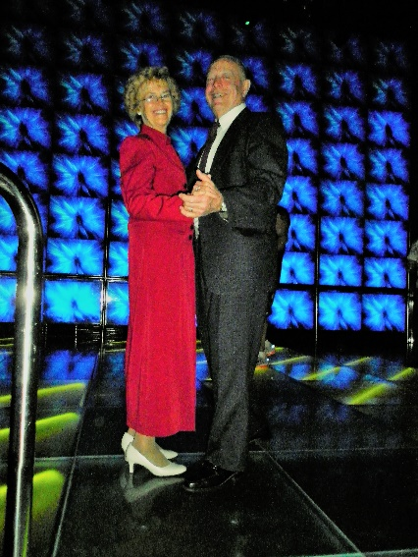We have always loved to dance.

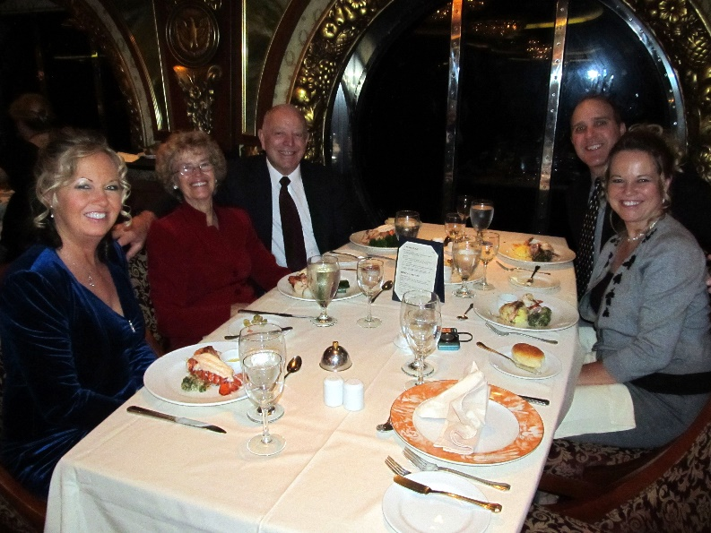Ken woke shortly after 4AM and mainly watched the ocean waves. After the sky started to lighten he saw tuna surfacing. Sandi and I came to the port window and watched them with him. The waves are quite large and the ocean very rough. It is interesting to walk around with the ship swaying. After a good breakfast, we attended a ballroom dance class and really enjoyed that. Sandi and I did some research of shore activities. When we came back, we went to the dance lessons. We then had some Suchi which was my first time. We came back and got ready for dinner. We met Roy and Shellie at the Monarch room and played Mexican Train Dominos until dinner time. We stayed for a show but I wasn’t very impressed.

We didn’t have a lot of activity except meals. We watched the movie “The Man Called Peter” using our computer and projector. It makes it a little crowded with 5 of us in our room. This afternoon we attended a dance class. We then came back and dressed in our best for the dinner this evening. We then went for pictures to be taken. They had many photographer’s taking many poses so that everyone had lots of chooses. We did have some time to dance in some of the Ball Rooms before going to dinner. This was the captain’s evening in the dining room. He spoke for a minute, but we really weren’t very impressed. After dinner we attended Show Time and the Big Band. We were tired but when we went past the Club Cool room we couldn’t resist going in and dancing until mid-night.

Ken and I went walking around the ship as the weather was much warmer today. It was fun walking all over the upper decks. The sun broke through the clouds and everyone was out sun bathing. We were able to use the swimming pool and they we quite warm. Sandi came and said that they wanted to play miniature golf, but I was tired, so I went, and Ken took a nap. An hour and a half later I came back and woke him. We went to a dance lesson but didn’t stay very long as it was basic Fox Trout steps. We looked at the pictures that were taken last night and picked some of what we liked. We came back to our cabin and watched the movie “The Ultimate Gift” and we all enjoyed it.

(This is taken from Ken’s journal – so he is writing this now). This morning when I woke my pain level was up. I will have to be stricter with my diet. After breakfast the five of us played the game “Trans America” and quite enjoyed it. Sandi and I attended the dance class. While we did that Mae went to our cabin and lay down for a while. We then went up to Roy and Shellie’s cabin and played “Mormon Bridge”. After getting started in the card game we attended the Magician show. Following dinner, we finished the card game we started earlier. It was late when we were ready to go to bed.

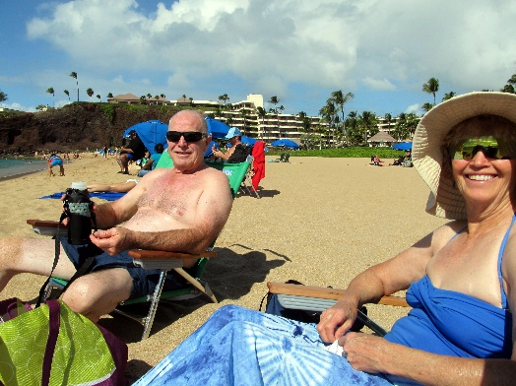We came into port about 10AM. It was neat to see us come into the island. Sandi, Mae and I took a bus tour to the Hawaii Volcano National Park. Roy and Shellie took a helicopter tour of the Island. On the way we stopped at the Mauna Loa Macadamias plant and saw how they processed the Macadamia nuts. We also bought some packages of the nuts for gifts and to eat. After returning we went to a show on board the ship and then to dinner. After dinner we came back to our room and the five of us watched “Heaven Can Wait” which was a cute show.

We arrived at Maui at 8AM and disembarked shortly after in order to be on our tour by 10AM. Sandi, Mae and I rode the tour bus to the Sheraton Hotel where we walked through their facilities to the beach. It was a beautiful sandy beach where we enjoyed the warm sun shine. We also enjoyed snorkeling and seeing the many fish. Back at the ship, we then went to eat and then attended a Hawaiian dance show.

This morning we were at the Island of Oahu. I woke with the pain level very high. We went for breakfast and then left for the tours. Mae, Sandi and I went on a bus tour of Diamond Head. Most of the stops, I stayed on the bus because my feet and legs hurt too much to walk very far. The tour guide was very good and we did enjoy the trip. I have really watched what I have eaten today but tonight I’m still in a lot of pain. When we came back to the ship I got me some chicken to eat and went to the cabin. Mae and Sandi went shopping. I took a nap. Mae and Sandi had a lot of fun shopping this afternoon. This evening I watched a show on TV. Mae and I went to bed early.

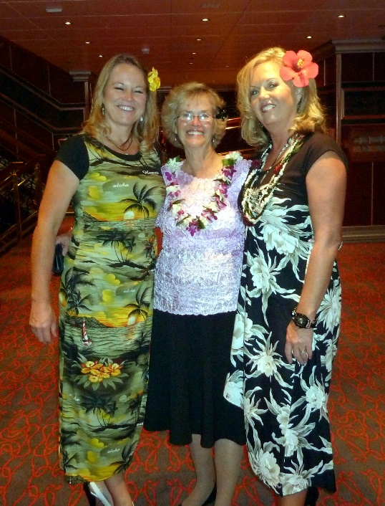This morning we were on the Island of Kauai. We set the alarm and was up at 6AM in order to be ready for our shore excursion at Kauai. Mae didn’t sleep very well last night because she was worried about me. I do feel much better today, although my feet are still tender. Roy and Shellie went four wheeling in the mud. Sandi, Mae and I went on the Waimea canyon & Wailua river boat tour to the Fern Grotto. It was a very beautiful ride up the river and then when we got up the canyon we docked and had a short walk up through beautiful jungle trees and plants to a cave. They only let us go to a view area because the hurricane had damaged the cave and loosened the rocks above making it dangerous to go further. When we got there the tour was to show and teach some Hula but it started to rain very hard. Finally, when it broke, they had everyone return to the boat where they gave us the show. It was good that they did because it rained more. This area has more rain than anywhere on the earth receiving over 400 inches annually. It was a very worth wile experience. When we returned Mae and Sandi again went shopping. I came back to the cabin and took a nap. This evening Roy, Shellie, Sandi, Mae and I went to the evening show, which was a Juggler Entertainment. We stopped for more photo shouts and went to dinner and then quit for the night.

Today we are on the Island of Hawaii, city of Kona. We had to get up early in order to be on time for our tour. The weather was very pleasant. Sandi, Shellie and Roy went on a tour where they were able to swim with wild dolphins. They also saw a hump back whale. Mae and I went on a walking tour in the city. My pain level is high, and my feet and legs hurt. For breakfasts I have been having scrambled eggs but as I finished eating this morning it dawned on me that they probably are using powered eggs mixed with water and milk. That was kind of dumb on my part. The tour was very good but by the time it was over my pain level was high. Mae and I set on a bench and ate a boiled egg. We were going to go through a museum when Sandi called and said that they were back from their tour. We waited for her to join us. I decided to return to the ship and let Mae and Sandi continue in town. I carried several items back with me so that they wouldn’t have to carry them around town. When I got back to the pier, I met Roy and Shellie. I also took their snorkeling equipment back to the boat with me, so they wouldn’t have to pack it with them. After dropping the extra items off at our cabin, I then up to the dining area and got something to eat. I then came back to the cabin and I fell asleep until Mae and Sandi came. We departed Hawaii about 4PM. As soon as we got out to sea the seas seem to become quite rough. We put on the DVD movie “Golden Plates”. It wasn’t finished when Shellie called just before 7PM. She reminded us of this evening’s entertainment. We paused the movie and went up to the theater. We were able to find Roy and Shellie there. The show was a musical and dance production that was very good. After dinner we ended up getting more pictures taken. My pain level was high so I found a place to just sit. When Mae came, we went downstairs to our cabin. Sandi wasn’t much longer coming to the cabin. We watched the rest of the movie and really enjoyed it. Roy and Shellie came down to get their scuba gear and while they were here, I had Roy give me a Priesthood blessing.

We are back on the ship. We slept in this morning. I slept fairly well although the pain level in my feet, legs and hips is quite high. I didn’t get up for breakfast, but Mae brought some breakfast down to me. Mae isn’t feeling very good this morning. She seems to have some congestion and a sore throat. The sea is quite rough this morning. The waves are very interesting to me and I think of the earlier mariners, especially the early Saints and also the scriptural accounts. Our cabin boy “Katut” came in to clean our room. This afternoon we played some card games. Mae is feeling worse, but she did go to dinner. My pain level is decreasing as the day goes on. We came back to our cabin after dinner and soon went to bed.

I am feeling much better, but Mae is feeling quite bad. I went up and brought back breakfast for the two of us. Sandi and Shellie went running and later some sun broke through, so they went sun tanning. Mae and I watched a movie on DVD titled A Walk in the Clouds” that was very good even though it was rated PG13. Both Mae and I took a nap. This afternoon we watched another movie “The Blind Side” and that was very good. Roy, Shellie and Sandi came down and we played some games. At dinner time Mae still isn’t feeling well. Sandi checked with the dining room and she was told that they couldn’t take food out. So, I went up to the 9th floor and got us something. We had just finished eating when our waiter from the Dining Room brought our dinner to us. They have treated us so good there. I put most of the food in the refrigerator for tomorrow. Mae went to sleep after eating but before she did, I gave her a Priesthood Blessing. I watched an old John Wayne movie and finished this entry before going to bed.

Mae was quite sick during the night with a high fever. This morning when she woke, she felt some better. I woke for a while, but it was still dark. I went back to bed and may have dosed a little. When we got up, we decided to go up for breakfast and then go to the hot tub. Sandi and Shellie also came up for breakfast at the same time. They had gone walking at 6AM. Roy decided to sleep in. After eating, Mae and I went up to the indoor spa and enjoyed it for a few minutes. We came down to our cabin and lay down. Mae laid took a nap while I worked on the computer. When Mae woke, we watched the movie “The Boy in the Striped Pajamas”. It was good but also depressing. I took a walk around the boat. The sea is quite rough, and the winds outside are strong. This evening the five of us got together and played games for a little while before getting ready for dinner. Mae and I were served a fish with tomato sauce on. I was concerned about the sauce, so I asked our waiter and he assured me that it had been made especially for us without any sugar. It was very good and probably the best tasting food we had been served. Mae wasn’t as happy with it as I because of the spices. After dinner we went to a dance where I danced with Sandi once and Mae once before we went to the Pharoses Palace for this evening’s entertainment. It was good as far as performance, but for Mae and I it was too loud, lights to bright, and costumes too revealing. After the program ended Mae and I came to our cabin and got ready for bed.

We are now in California’s time. I woke at 4:30 and not being sleepy I took the camera and went up to the 9th floor. I fixed me a cup of hot herbal tea. We found that using our protein powder as a creamer with the tea makes a very pleasant drink. I wanted to go up on the top deck, but it is still closed off due to winds, so I walked around the ship for a while. I went out on the side deck on the 3rd level but it was dark, windy and then it started to rain, so I went back to our cabin about 6AM. I went back to bed and after a while fell asleep. When I woke again Sandi had left and the skies had cleared, and the sun was shining. Mae and I went up for breakfast about 10AM. Mae still isn’t feeling good so we tried to find somewhere outside to lay in the sun but the wind is still cold, and we didn’t want Mae to get cold so we came back to our cabin. Our cabin had been cleaned while we were gone. That has been one of the fun things about this cruse is to have the cleaning and cooking all taken care of for us. Mae went back to bed and I read a couple of chapters in the Book of Mormon before working on my journals. Roy, Shellie, Sandi and I started to play miniature golf, but the winds were so strong that we quit. Sandi, Shellie, Mae and I played a short game of Hearts before we went for our dinner. This evening for dinner Mae and I had pork steak that was very good. We attended the evening program, but I wasn’t very impressed with it. Mae and I came back to our cabin and soon got ready for bed.

I woke at 6AM and soon went up to the 9th deck where I could see the sun rise. I took several pictures and just marveled at the beautiful sun rise. I couldn’t help but think of the scriptural reference as to “Why does God consider my worth when He has such creations.” I hadn’t taken a coat with me and it was very cold so when I got back to the cabin, I got back in bed to warm up. We went up to breakfast about 9:30AM and then at 11AM we attended the debarkation meeting. From there we went to the dance class. We spent the rest of the morning packing. Sandi and Shellie participated in a one-mile walk St. Jude Children Fund. After lunch we continued the packing. The ship got into Ensenada about 4PM. After it docked Shellie called us and said that they could see seals from their cabin deck. We went up but as the men tied the boat it scared the seals into the water. After we watched them in the water for a few minutes, Roy, Shellie and Sandi left to go into Ensenada shopping. Mae and I continued to watch the seals return after the men finished securing the ship and left. We stayed until one large seal climbed up the rocky bank and lay on the shore. More would have followed but a man kept walking on the dock to see the seals, so the seals would not get out of the water. We finally went back to our cabin. Mae became very worried about the kid’s safety and, so we had a prayer asking for their safety. Mae and I then went up to the 9th deck and got us some bean soup. While we were eating Mae over heard a lady and she was very upset. The lady’s husband was in a wheelchair and she had evidently had a run in with some of the passengers while she was trying to get both her and her husband’s dinner. She was about in tears, so Mae went over to her and visited with her for a few minutes. That is one of the neat characteristics of my special wife. She is so concerned about others. After eating we went to the game room and played a game of Rummy in which Mae won. She does that quite often. By the time we finished the game Mae was getting quite worried about the kids. We just started to go looking for them when Sandi came. Mae was very relieved. They had found a tour bus at the dock that took them around the city and then to a store, so they could get some vanilla. All of us went dancing this evening and had a lot of fun. It was mid-night when we got to bed.

I got up at 5:30AM but Mae and Sandi slept a little longer. We went up for breakfast at 7AM and then came back to the cabin and finished getting the suitcases ready to go. I took a short nap. It took us quite a while to debark but the customs came onto the boat so when we got through them, we went right off. Sandi’s arms started hurting her, so I pulled both her luggage and mine. Mae did pretty good with hers. Roy and Shellie weren’t far behind us. Shellie’s bag had trouble with its wheels so that was a little difficult for her. We left L.A. about 12:30PM and traveled straight through with only a stop for Subways sandwiches. We got to Sandi’s at 12:30AM, so with losing an hour time with time-zone, we made it in just about 11 hours. We were very tired and sure glad to be staying at Sandi’s.

**Our family went to Payson Lake for some vacations.**

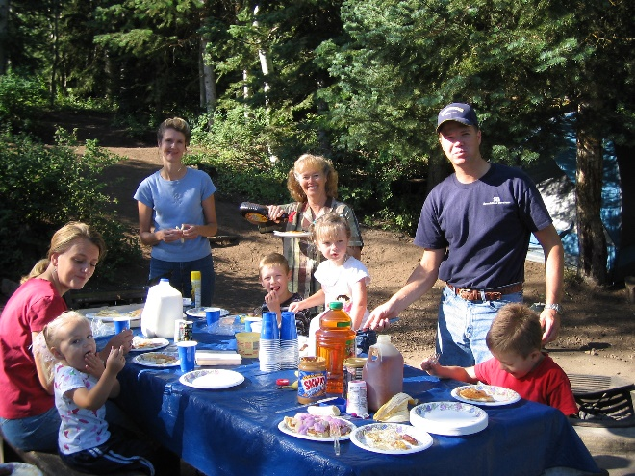 Most of the family just came up on Saturday to spend the day. David was studying hard as he was in medical school, but Shauna came and brought her kids. Mike, Becky and their family came that day too. I think Jeff, Gail & the children stayed the weekend with us. I can’t remember if Scott, Mishelle and their family came. Sandi came and I think she brought Dawson, but not sure if she did. It rained part of the time and cooled off at night. Sandi had brought her shade tent so we put it over the table and we played games under it even though it was raining. Shauna and the kids hadn’t brought jackets, but we had some extras, thank goodness as it was quite cold. **(This picture is of another time our family went to Payson Lake. It was in 2007.)**

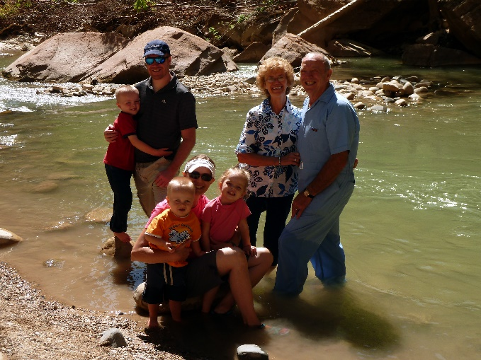We again went to Zion’s Canyon, in October for the school’s fall break as Ben and Rachel are both in school now. Jeff, Gail & family came down on Monday and stayed the week. Their friends, Stewart and Nisha came down for the last couple of days too and they had reserved places for them and Jeff & Gail to go repelling. Ken and I tended Jeff & Gail’s children while they went. Sandi and her family went on the shuttle bus and trails that day.

Jeff had told Nolan that he should come down with Stewart and Nisha. Nolan and his family were coming to St. George and staying at a condo for that weekend, so at the last minute, he did come. He told me that when Jeff said that I would love to have him there, he wanted to come. Nolan is a cute nephew and we have always had a close relationship. I took Jeff’s children over to the sand area to play and Nolan came with us. He was cute with the children. Ben brought his insect net and container and wanted to catch lizards. He and his dad had caught some the day before, but his dad had him let them go that night. I promised him we would catch some, so Nolan played with Rachel & Matt in the sand while I took Ben to catch lizards. We did catch some, but he wanted to catch more so later Nolan went with him. Nolan’s leg is really bad, so it was hard for him to walk very far. We sat & visited some. He slept in the camper with us on Thursday night. Stewart and Nisha slept in our tent as Jeff & Gail brought Gail’s mother’s big tent for them to sleep in. They didn’t bring food, only snacks so ate meals with us. We were a little surprised that they didn’t offer to pay anything on the food, nor did they really thank us. Oh well, they’re nice people and good friends of Jeff & Gail’s. We brought Sandi’s table over and made a big family table with the two tables, so everyone could eat together and that was fun. We brought our big shad tent and put it up over the tables so in case it rained. It was colder than we expected this year. We also all crowded into our tiny table area in our camper and played games. Ken wasn’t feeling good the one night so went to bed. There was Sandi, Chelci, Nathan (who watched), Jeff, Gail, Stewart, Nisha, Nolan and I playing. It was crazy, but we had fun.

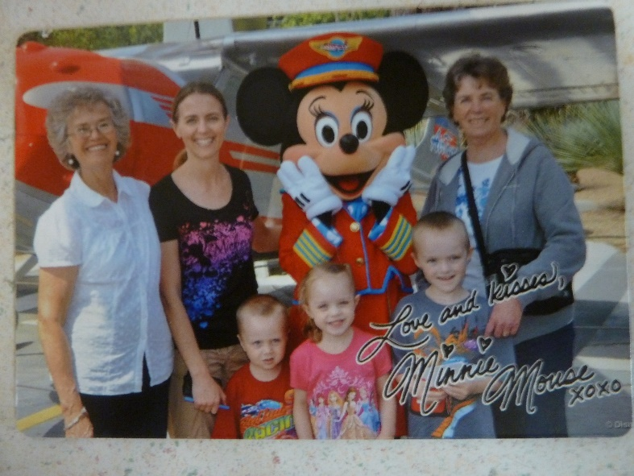**Disneyland with Gail, her children and her mom, Marcy in May of 2013** - Ken and I were at Jeff & Gail’s one Sunday evening playing games when Gail started telling us that her and her mom were taking the children and going to Disneyland in May. She said that Jeff was going to take off a couple of days to fly down and meet them and be with them for a day and fly back. She said he didn’t have much vacation time, but she wanted him to be with her and the kids for part of the time.

In talking with them, it turns out that Jeff really didn’t want to go. He’s like Ken, he doesn’t like amusement parks and he didn’t have time to take off. He said: “Mom, you would like to go in my place, wouldn’t you?” He caught me off guard and I told him I would love to be with Gail, her mom and the kids, but that I needed to be home with Ken to keep him on our strict diet. He asked Ken if he wouldn’t be alright for a week as he thought it would be great to have two grandmas’ and their mom. That way each child could have someone to be with and go on rides with. Anyway, it turned out that he talked me and Ken into it, and Gail too, however, she was disappointed that Jeff couldn’t go. Jeff told me that since I would be going in his place and doing a favor for him, he would pay for me to go. I ended up going and having a wonderful time. Ken and I missed each other, but it was good spending more time with Gail and the children. Marcy was great about it too and I enjoyed being with her also.

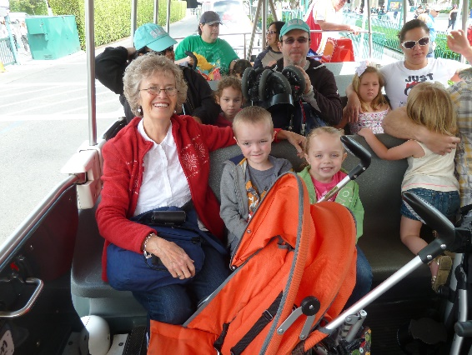**Marcy** took her vehicle and she packed all of us into it and all our luggage. She drove most of the time with Gail trading her off for a break now and then. I was willing to drive, but relieved that I didn’t have to as I was nervous driving her vehicle with all the precious cargo. We stayed with Gail’s sisters and their families. We stayed at Lisa & Ralph’s in St. George on the way down and back and we stayed with Debbie and her husband and children the five days we were there. We spent three full days at Disneyland and we had two down days where we could rest and relax at Debbie’s house and the children could have naps since we stayed late each time we were at Disneyland. Debbie and 2 of her children came one evening as they have a season pass. We took lunches with us and we bought the evening meals there. Gail took two strollers so Rachel and Matt didn’t have to walk all the time. That worked well, so we could put our lunches, etc. in them too. It was so fun watching the expressions and excitement as the children rode the rides with us or got their books signed by the princesses or cartoon characters – Mickey Mouse, Miney Mouse, Donald Duck, Pluto, Goofy, etc and also got pictures with them and with the Cars – Lightning McQueen, Mateur, etc. I enjoyed most of the rides, but there were a couple I wouldn’t go on again as they were too hard on my back & neck and they were too frightening for me, for the children too. The children were really good most of the time and it was a lot of fun. Gail had bought me a Disney T shirt for Mother’s Day as she wanted us all to match when we wore them there one day. That was fun too. Marcy is a wonderful person and Gail is a special daughter-in-law and great to be with. She is usually always happy and bubbly and excited about life, which makes it great for all of us. I was worried about staying with Gail’s sister’s and families as I am not one of the family, but they were all good to me and said they were glad to have me.

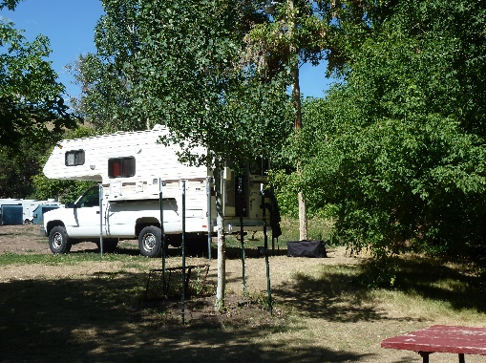**Camping and fishing trips with my honey, with our boat and camper the summer of 2013-** Since Ken and I didn’t get to use our boat and camper much last year because of working on preparations for the large Bushnell Reunion which was held in Tropic at Keela’s property in August, I decided we needed to use them more this summer and, so we had to plan way ahead to get reservations at the places we wanted to go. I went over the calendar, selecting times we could be away and then I showed Ken and talked it over with him. I then made reservations at **Hyrum Reservoir for five days**, Monday through Friday in June. I made reservations at Fish Lake for a week in July and I made reservations for a **Monday through Saturday at Payson Lake for August**. I also talked to Ken about us going to **BYU Education Week** the 19th through the 23rd of August as we have wanted to do that for a couple of years, but never got around to registering for it. He said to go ahead and make the reservations**.**

We invited any of our family to join us at **Hyrum Reservoir** and David, Shauna, Emily & Connor came up on Monday and stayed overnight and the next day. Tyler was at basketball camp in St George. We had a great time fishing, relaxing at our campsite, playing games, eating, etc. We were glad they could come.

We also invited Bryce & Deanna and they came up for a fish breakfast with us one morning and stayed most of the day. We enjoyed being with them and had a good visit. Deanna and I don’t get a change to visit together often, so it was great!

We thought that Sandi & Nick could go with us to **Fish Lake** as they always have. This year, 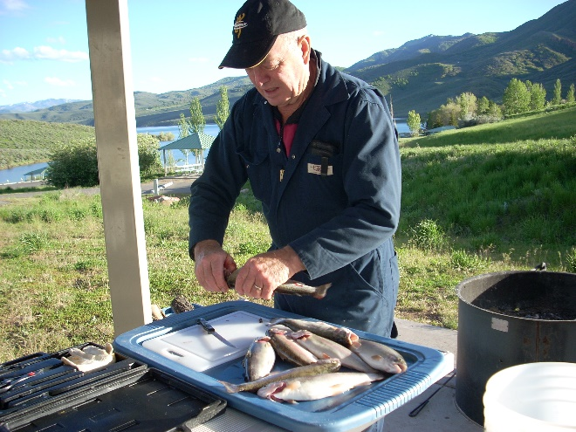however, the government was furloughing the government employees and he works for the government as a guard at Dugway Proving Grounds, so he wasn’t able to go and Sandi had already booked a vacation with one of her friends to Glazier National Park and Canada for two weeks, so she couldn’t go either. None of the others could go, so Ken and I still had a great time fishing and camping together. There was a good family camped by us which we got to know and enjoyed visiting with them. They were kind to us by taking us in their truck down to our boat. Ken and I love to be alone together anyway. We have fun whatever we are doing, especially vacationing. We have gone fishing at Strawberry Reservoir together also and staying overnight in the cabin there. That was fun too. Ken and Nick have gone together fishing both at Strawberry Reservoir and East Canyon Reservoir.

**In August of 2013**, Ken and I reserved a campsite for a **week at Payson Lake**. it ended up that only Jeff, Gail and the children were going to be with us for Friday night and Saturday and they were going to use our tent and share our campground, but Sherrie, Bob’s daughter had passed away from a liver disease caused by drinking alcohol, so we needed to leave on Friday as the funeral was early Saturday morning. When Jeff found out about it, they decided they wanted to go to the funeral so wouldn’t be coming up. We asked Scott if Kylan could come with us as he loves to camp and fish. Kylan was excited, so we had fun playing games together in the evenings and he and Grandpa went fishing several times. Sometimes they caught some fish and sometimes they didn’t. Sometimes I would stay and read in the camper and other times I would take my camp chair and book and watch them. Kylan loved the meals and snacks we had. He’s a cute boy and we enjoyed having him with us. Mike couldn’t come up, but Becky brought Maddi & Jessie and Jessie’s friend and spent part of one day with us and had supper with us.

**Vacation to Shellie & Roy’s in May 2014**

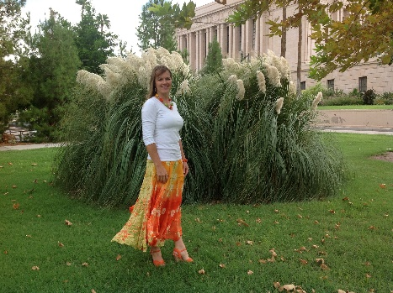I haven’t been home much in the last 4 weeks as I went to Shellie & Roy’s home for Garrett’s graduation from ASU and Kevis’s high school graduation. I had a wonderful two weeks with them. We did lots of fun things. They have a beautiful boat so we went to the lake one day and Garrett, Nora & Little Maggie went with us. Both Garrett and his mom are fantastic on the water. Roy is recuperating from his hip replacement operation so he didn’t do much, but he did get out on the wakeboard one time. Jase, Nora & I got on the knee board (at different times). My broken elbow was still healing so I didn’t dare do much either, so they just pulled me around as I laid on the knee board. Nora got up on her knees. She was really nervous at first to even get out on it, but she had fun. Shellie & I played lots of games at their home. Nora played with us when she was with us. Neither Roy, nor any of their sons like to play board and card games. We watched several movies in their theater room and Shellie and I did lots of visiting as we went shopping, doing laundry or just sitting and talking. We went to the Mesa Temple and took pictures on the grounds, after the session. Shellie is a beautiful and special daughter.

Ken really missed me, I missed him too and wish he could have gone, but they needed him to take his school bus route, especially at the end of the year as they have lots of field trips and sports events. Ken picked me up at the airport at 6 pm on Memorial Day and we were happy to be together again. We went out to dinner and enjoyed the evening together.

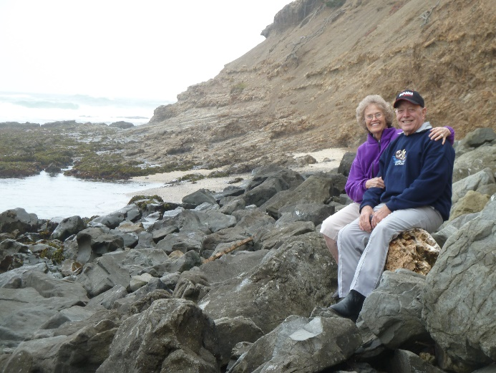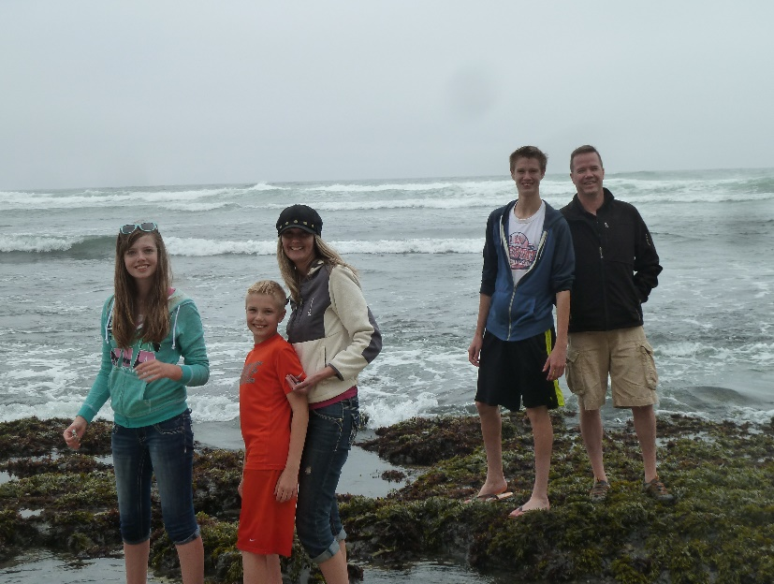**VACATION WITH DAVID, SHAUNA & FAMILY TO CALIFORNIA IN JUNE 2014**I was busy doing laundry and repacking to leave on vacation on Friday morning with David, Shauna and their family. Her parents went also. Shauna is great in planning vacations and making all the arrangements, so we had a great time. We stayed in a home on the beach at Half Moon Bay. It was beautiful and so was the ocean. It was a little chilly as it didn’t get over 62 degrees, but it was so pretty. We were down at the ocean several times, then going on the paths in the park across from this home where the path overlooked the ocean and we saw lots of seals resting on the rocks or on the beach (depending on when the tide was in or out.). In the mornings they have “tide pools” where you can see all kinds of animal life. We saw star fish, squid, snails, crabs, sea urchins, etc. We drove down to the pier one afternoon and went fishing for large crab. That was a fun experience too. We stayed two nights there and then drove to Yosemite where Shana had rented a cute ranch house for us on this large ranch about 40 minutes from Yosemite National Park. We had all the comforts of home there too, plus it has beautiful surroundings. Tyler, Conner, David and Ken played horse shoes and several of us got in the hot tub. We also hiked a mile to their fun pond where they had paddle boats and a canoe. That was lots of fun. The next day we went to Yosemite and spent the day. It was so beautiful and the weather was just perfect. We all enjoyed it so much. The only thing that was hard was finding parking spots for all three cars as we drove from place to place. There were so many tourists there. The following morning, we drove 11 hours to St. George. The children took turns riding with their parents and both sets of grandparents. Shauna’s parents have bought a condo in St. George so we all stayed there for two nights. We swam in the pool, played games, visited and Shauna, Vickie (Shauna’s Mom) and I 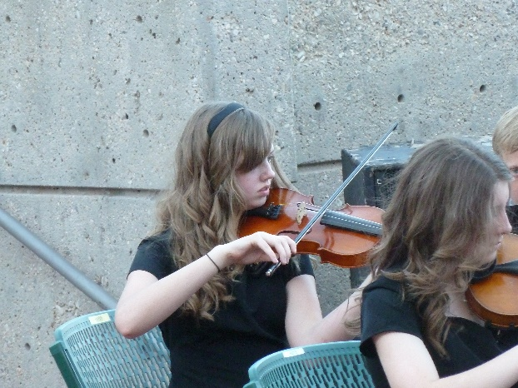went shopping**. Emily plays the violin very well now and is in a small strings orchestra and they performed prior to the play “The Wizard of Oz” at tuacon**. We also had tickets for dinner there and it was very good. I was afraid it would be really hot as it had been 108, but the sun had gone behind those beautiful red mountains so it wasn’t so bad, in fact it was quite nice.

Ken and I drove home the next day and stopped at Mike and Becky’s to visit them. They had us stay for dinner and while it was cooking, we played Rook. David, Shauna and family stayed at St. George an extra day, but I needed to get home to teach my primary class as the other teacher had taught 3 weeks in a row for me. We experienced cool weather at the ocean, beautiful warm weather in the mountains at the ranch house and Yosemite, and then hot weather in St. George. Quite a vacation. We are still tired from all the traveling (we traveled about 2,500 miles on this trip, but it was sure fun

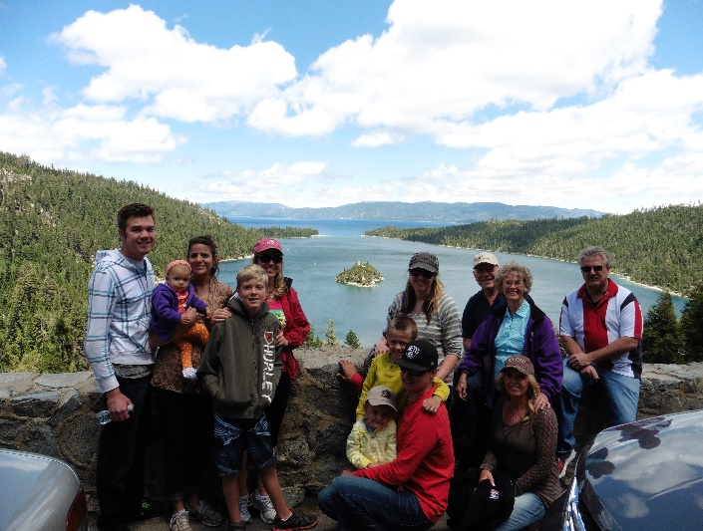**LAKE TAHOE WITH SANDI, NICK, CHELI, STEVE & CHILDREN, SHELLIE, ROY, GARRETT, NORA & MAGGIE AND KEN & I**

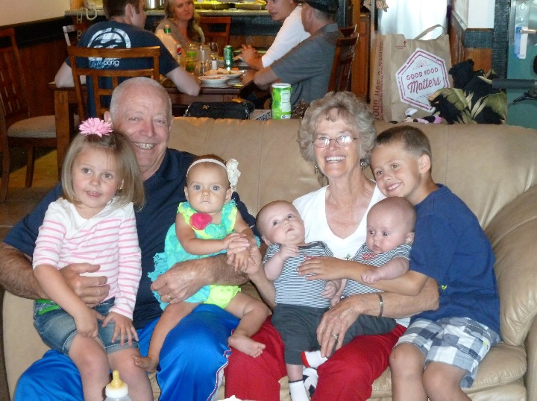Sandi had two-time shares at Lake Tahoe, so she invited Chelci, Steve & their children, Ken & I, Shellie, Roy, Jase and Garrett, Nora & little Maggie came with them. Sandi & Nick and Chelci, Steve & children stayed in the one in downtown Lake Tahoe and Shellie, Roy, Jase, Garrett, Nora & Maggie and Ken & I stayed in the one up in the mountains. Both places were great and so different. We took turns fixing the meals and when we were with Sandi’s group, we had delicious meals that Sandi & Chelci prepared and afterwards we would go swimming in the pool or play ping pong and other games. Ken & Nick played Chess with big chess pieces by the pool. We also went shopping and to the art festival downtown. When Shellie, Nora and I fixed meals, the others came up to our place. There wasn’t as much to do where we were, but the view and scenery were spectacular. The accommodations were great at both places.

We went on outings to the beach at the lake one day, another day we went sightseeing and hiked some. We saw beautiful waterfalls; we walked down to a mansion and went through it. We did lots of fun things and had a great time. However, Nick & Sandi were having problems and while walking with Sandi, she told me that she hoped I wouldn’t hate her, but that she was going to divorce Nick as she couldn’t take it any longer. She said he didn’t want to do anything fun, all he wanted to do was watch sports. He didn’t help her with the yard or housework, he didn’t show her affection and she said she had about 20 more good years and she wanted to have fun and do things. I told her that I certainly wouldn’t hate her, that she was my daughter and I loved her very much and I wanted her to be happy.

**KENNETH H BROWNING FAMILY REUNION – Held July 10 to 14, 2014**

**Held at our home in Clinton – great fun with family (Put in pictures)**

**Thursday, July 10, 2014**

After breakfast I went over and got Kylan and then up to David’s and got Conner. The two of then helped us get the yard cleaned up and mowed the lawns. Time went very fast today. Scott and Jeff came over after work and help us get things ready for tomorrow. Storm threatened so we did not put the canopy all the way up, but will finish it tomorrow. Shellie and Jase arrived here this evening. We were up late visiting.

**Friday, July 11, 2014**

We got things about ready. We started to prepare the Dutch ovens but needed Sandi’s. She let us know she was on the way. A short while later she called to tell me that she had just blown a tire on the trailer. She was on the Legacy Highway by Bountiful. A young man stopped and helped her. I had Shellie and Mae drive to help her but the young man drove her to Bountiful where she bought new tires for the trailer. Mae and Shellie got the stove and Dutch and brought it back to me. I had all the chicken browned with part of it in the kitchen oven as I only the two ovens Dutch ovens. They got back just as I was starting to load the vegetables in with the chicken. I was sure busy without having Mae or anyone else to help me. As it was they got back just in time and I was able to get the three ovens going. It turned out to be a very good meal. Mike and Becky didn’t come but Becky brought Maddi and Jessie and met Jeff in Salt Lake and he brought them on. Mike is still sick but hopes to join us tomorrow. It was interesting getting everyone’s campers set up, as well as cleaning up the Dutch ovens and help set up a screen and outdoor projector so that we could watch a movie tonight. I think everything worked out ok but it was after mid-night before we got to bed very tired.

**Saturday, July 12, 2014**

David and Shauna prepared breakfast of hot cakes and eggs, they were very good. The children sure enjoyed the swimming pool. Every one enjoyed visiting, playing games of all kinds from table games to volleyball. Gail and Shellie bought sandwiches from Wall Mart. Mae had thought that everyone would enjoy going water skiing at one of the lakes or going to a water park but they all wanted to continue visit and playing games. The little ones played constantly in the pool plus we had water balloons and water guns so they were having fun all day. Scott and Mishelle provided the evening meal of spaghetti with homemade rolls. Having the portable toilet was a help plus we went through lots of water and cups but it was a great day. David and Sierra came for a while this afternoon and both seemed to enjoy the activities. Some of the children wanted to have another movie but I think everyone was too tired of having fun to stay up late for a movie.

**Sunday, July 13, 2014**

Sandi and Shellie made muffins, scrambled eggs, special fruit drinks for breakfast. Shellie and Jase went to Sacrament meeting with us and Gail took the children to their Ward so that Ben could sit on the stand with the Bishop. I feel bad that none of the rest of our family are not more active. We only attended Sacrament meeting but it was sure special. There were a lot of visitors today as the Searl boy is leaving on a mission on Tuesday and Jake Steadman just returned last Tuesday. Both of them gave very good talks. Mike and Becky haven’t been here as Mike has been sick. We are glad that Mattie and Jessie have been able to be with us. We played a lot of table games again this afternoon. Scott and Michelle prepared South West Chicken for lunch and that was sure good. This evening we just had left over’s and hot dogs for some of the children. Mike and Becky did come this afternoon although Mike is some better he still isn’t up to par. It has again been a very enjoyable today. We have had all our children, and many of our grandchildren, plus with Chelci coming Friday afternoon with her children, that made 4 Great Grandchildren that attended. Jeff and Gail took their family home tonight, plus Scott went home as he goes to work quite early. Mike took his Family home this evening.

**Monday, July 14, 2014**

Bob prepared biscuits and gravy for us and I fried up quite a few fish, so we had a big breakfast this morning. Everyone helped clean up and then everyone soon went home. Shellie and Jase went to Shellie’s friend, Brook, who lives in Sandy Utah. They will stay there for a couple of days and then head for home. Mae and I laid down and took a nap, although Bob knocked soon after we laid down and woke Mae so she didn’t get much sleep. We finished getting everything put away. Scott and Mishelle came back this evening to get some of their things out of the trailer. We were sure tired when we went to bed, but we did watch the series of WAR. I wasn’t very impressed with the show. It was mid-night when we went to sleep.

**VACATION TO FISH LAKE AUGUST 16, 2015**

Ken and I left for Fish Lake after we left the Bushnell Reunion. It took us until 5pm before we checked in at the Fish lake RV Campground. It took us a while to get set up and was soon ready for bed.

**Monday, August 17,** we slept in the next morning, and after getting up, Ken started looking for the sewer hookup. When he couldn't find one and all the other pads had one, he went to the front desk and asked them about it. The girl there said that they had had a bad rain storm and haven't found the hook up on that pad since. She gave him a new spot #26 and we moved. Most of the day was spent relocating. We went out fishing about five and did catch four fish before dark.

**Tuesday, August 18,** we got up at five am and were on the lake shortly after 7 am. It was a beautiful morning. I caught the first fish. By 9:15 am, we had each caught our limits. I hooked another one while reeling in, that we released. It was another great morning. We stopped at the lodge to see if they carried any groceries, but not much. Ken cleaned the fish while there as they have a better cleaning station than the one at Bowery Haven. We then went to the dock on the south west end of the lake, but they had the same selection of groceries as the other two. Ken filleted and packaged the fish while I got some lunch. We ate and then took a nap. I got dinner ready for the evening, while Ken wrote in a note book for his journal. We went out fishing about 4:30 pm and though there was a lot of wind, we both caught our limits, in fact, as I was bringing in my last fish, as Ken reeled in, he caught another fish. It was a lip catch so we released it and it swam away. I read President Uchtorf's talk on the Savior's Atonement. It is sure a great talk. Ken cleaned our fish while I went on to our camper and started dinner. After dinner, Ken filleted the fish and I packaged them. We are getting quite a few fish. We are tired so we are soon going to bed.

**Wednesday, August 19**. We got up early so we could have the crockpot on before we went out fishing. It was windy when we woke, plus Ken wasn't feeling the best, so we went back to bed. After getting up, we realized that the furnace wasn't coming on and it was cold inside the camper. Ken went to check the thermostat and realized that the crockpot was setting right under the thermostat. We moved the crockpot and the heat soon came on. About 8 am we went out fishing. It was a beautiful morning. By 10:45 am we were back in with our limits. Ken tried fishing for Mackinaws, but didn't get a strike there. We kept the lure out but he also fished with a 2nd pole. I caught five fish and Ken three. We had a good time. After lunch, we cleaned and filleted the fish. We took showers and a nap. I made a southwest chicken dinner for this evening. We went to the store for some ice, but they didn't have any. Then we went for a walk. After getting back, we played Rummy Cube in which Ken won two of three games. We got to bed before 9:30 p.m.

**Thursday, August 20, 2015.** We both slept well last night and were up at 5 am. We enjoyed a nice breakfast of hot cakes and eggs. We enjoyed the warmth and conveniences our camper gives us. We were on the lake about 7 am. Ken tried fishing deep with the down rigger and it worked pretty well. We both fished with our standard pop-gear with me catching my limit before Ken did. Ken still had one to have his limit and he hadn't had anything go for the down rigger lures. As he was letting his line out to try to catch his last fish, I asked if I could hold his pole while he took a picture of me fishing. He no sooner clicked the picture when the pole doubled over. Ken kidded me that I just wanted to catch his last fish. We were back in the boat dock about noon. I went up to start lunch while Ken cleaned the fish. After eating lunch, Ken and I filleted and packaged our fish. We then took a nap. I didn't get very much of a nap as a neighbor's dog started barking. We went out again this afternoon and Ken again spent his time trying to catch a lake trout. We had quite a wind on the lake this afternoon so I fished for regular trout and Ken spent my his time trying for the Mackinaws, and keeping the boat under control with the strong winds. I caught my limit but Ken didn't have any luck. I read some talks from the conference Ensign. They were very good. When we were about back to the dock, the wind let up. Ken tried to just catch a fish before we finished. he had a good strike and for the 2nd time today, the line broke and he lost a 2nd set of good pop-gear. We decided that the line must be getting old. Those pop gear sets cost about $20 each, so that hurts. We had a nice dinner, took care of the fish and went to bed about 10:30 p.m.

**Friday, August 21.** We planned on getting up early, but we decided we were too tired so went back to sleep. We got up about 6:30 am. We were on the lake shortly after 8. By 10:15, we had our limits and then just road around on the lake, just enjoying the morning. There was a fair wind, but it was still a beautiful day. We came in about noon. I helped Ken clean the fish and then he stayed and filleted them. We figure that we have caught over 48 fish this week and used 39 worms. When Ken cleaned the bait box, there was 2 ½ worms left. After lunch, Ken had me lay down, as I wasn't feeling very well, and he packaged the fish. he then took a nap outside as he didn't want to wake me, but was woke up with a wind that took the canopy almost down. It woke both of us, so we finished taking the canopy down and put it away. Ken and I played games this afternoon. This evening, after dinner, we went for a walk. We went north east on the lake shore trail, although it didn't go close to the lake. While walking, we saw a 3 point white tail buck, still in its velvet. A short way further, we saw a doe. Neither deer seemed very worried about us, but just kept their eyes on us. It was a beautiful evening.

**Saturday, August 22.** We slept in, not worrying about fishing today. After breakfast we started packing. We were glad that we had the canopy already packed as it still took us until 11 am before we got away. I was amazed at how Ken was able to back up the boat with the camper on, down that short, but steep dock. Then he ran around, got in the boat and drove it over and onto the trailer. It wasn't quite on, so he had to get out on the boat trailer and jump over to the cement edge of the dock. He walked to the front of the trailer and again jumped from the cement onto the top of the trailer to pull the boat the rest of the way upon the trailer. The boat wasn't on right, so he again jumped to the boat from the cement pavement and rocked the boat and threw me the rope to pull it up. Other men were standing around marveling at how Ken, as old as he is, could do what he was doing. One man said, I couldn't do that; I would fall in the lake. Ken is amazing, and I am proud of him for all he can do. I am not much help to him, so glad he can do it. Our neighbors to our right had come up last night and while we were packing, he helped Ken carry the canopy and put it in the boat. Ken had been worried about that as he didn't want me to help carry it. We stopped a couple of hours to visit with Mike and Becky. Mike did an excellent job with the remodeling of the girl's bathroom. It was 5 pm before we got home and it took us another 3 hours unpacking. We had stopped in Layton and got some Maddox chicken for dinner. We did watch a movie on Netflix before showering and going to bed.

**ARIZONA VACATION**

On March 9th, 2017, we left for our vacation to Shellie, Roy & family’s home in Arizona. Ken got home at 12:15PM and we got away at 12:30PM. Ken drove until we got past Provo and then switched and let me drive while Ken took a nap. He slept for over an hour then we switched again. We called the Class’s before getting to St. George and they met us at the Golden Corral where we enjoyed eating dinner and visiting. We then followed them to their home. We enjoyed our visit with Maggie and Bill, and then Maggie put a cartoon DVD on the TV. Ken was dozing off so Maggie offered him a blanket and within seconds he was out. When the show ended. we soon went to bed.

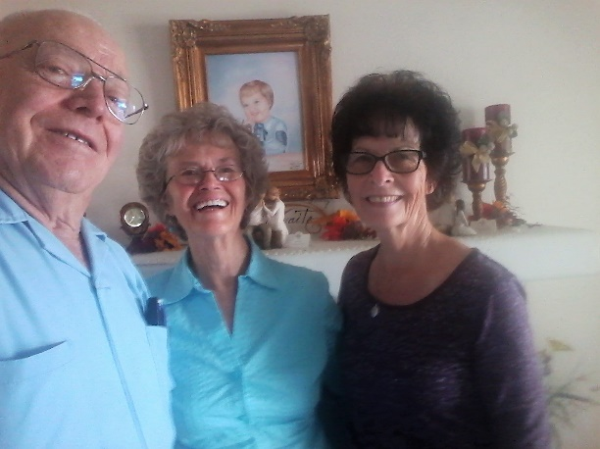 Billie cooked us a wonderful breakfast. We pack the car and left at 9AM**. With the use of the GPS we found Tammy Braithwaite’s home.** We were just a little concerned as to what reception we might get, but when Tammy opened the door, she just starred for a few seconds and then throw her arms around me and we both just cried. We had a wonderful visit with Tammy leaving there just before noon. Before getting on the freeway we fueled up the car and got us a Hot Dog for lunch. From St. George we drove straight through to Chandler with just a stop to switch driver, so Ken could take a nap. We arrived there at 6:30PM in time for dinner. We visited, and Roy and Ken argued some and I was worried about how this vacation would turn out and I wondered if we should have come. We soon went to bed. I prayed it and it went okay the rest of the time between them. I talked to Ken and Shellie must have talked to Roy.

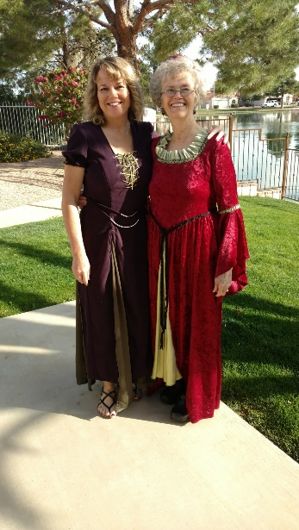We slept well getting up about 7AM. **After breakfast Shellie & I dressed in cute medieval dresses that Shellie had made for us. Wow, both she and Sandi are so talented in about everything. They surely amaze me. Shellie had told me by phone to come a day earlier so she could take Maggie and I to the Renaissance Festival**. She paid for our $20 tickets. Shellie and I got on our way and stopped to pick up Maggie at Garrett & Nora’s cute home. Nora fixed Shellie’s hair and I looked around their cute home and played with Maggie & Damon. We then went to the Renaissance up by Apache Junction. It was great, and we had such a good time. The only problem was it was “hot”. It was in the high 90’s and it is supposed to be in the “70’s” in March in Arizona. It was still fun, and I sure enjoyed being with Shellie & Maggie. Maggie was so cute and so good. Shellie spoiled her by buying her fairy wings to go with the cute costume she had bought for Maggie to wear. She also bought her a cute ceramic fairy and other things. There 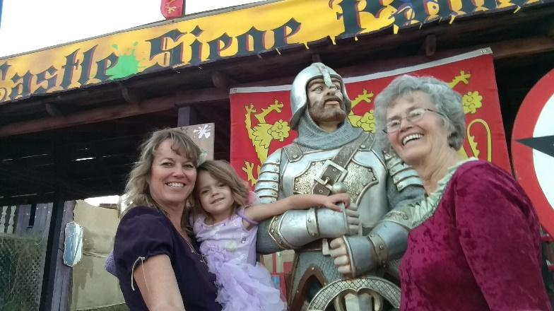were all kinds of things to see, food to buy and things to do there depicting the Renaissance period of time. They had a lot of entertainment including Jousting performed by a theater group. It really looked authentic. Ken later told me that he didn’t have a great day, that he had gone with Roy & Quint to the park where Roy and Quint flew Roy’s drone. He said that Roy didn’t even offer to let him fly the drone. Shortly after returning home Roy and Quint went bike riding. He felt uncomfortable around Roy, so glad they left. He watched a John Wayne movie, and after getting himself some lunch, he took Jase with him to get frozen yogurts. When they returned home, Roy and Quint were playing video games on the TV and Jase went to doing his thing on his computer. He said he got himself some more leftover Lasagna and waited for Shellie & I to return. He wasn’t very happy when I got there as he didn’t expect us to be so long. It was about 8:30 pm after taking Maggie to her home and then getting back here.

After a good breakfast that Shellie made, Ken, Shellie and I attended Block Meeting this morning but no one else attended. This is sure a heart ache for us. Mike is the only one of our children that is active in the church now although Shellie is trying but does not have her spouses support. This evening Quint and Roy got quite involved in a discussion of the future of the earth and the destiny of man. Ken said he wanted to yell at them “Where is your faith in the Gospel?” but he just remained silent and went into the other room. Garrett, Nora, Maggie and Demon came over this evening and had dinner with us. It was sure good to be with them, but there again Nora is trying to stay active, but Garrett is doubting his faith. He still goes to church with Nora and the kids and has a calling, thank goodness.

We were late getting up but what a beautiful morning. Shellie, Ken and I played Rummy Cube for a while. It has been a very relaxing day. After dinner this evening we watched a show on DVD titled “The Express” a show taken from a true event. An African American, Ernie Davis in the early 1920’s chose to become a Foot Ball Player and succeeded to be a Huysmans Trophy winner. Though he succeeded in football the sad thing is that at age 23 he dies of Leukemia. It was a good show although occasionally profanity came out and especially the Lords name was used in vain. We were late going to bed.

We slept in late and had a late breakfast. After getting up, Ken and I enjoyed breakfast on the patio. Shellie had gone for a bike ride before we got up. This afternoon Ken, Shellie and I took our car to a car wash and then we went groceries shopping. After returning home the three of played Three Handed Rook at which I won. This evening we all watched “Man from Snowy River” before going to bed.

Ken and I got up about 8AM and went for a walk. The citrus is out in blossom and they sure smell good! It looks like there are so many trees that the fruit is just being left to spoil and fall off. Anyway, we had a enjoyable walk to start the day. Ken has worked on “Indexing church records” some while we have been here. Shellie, Ken and I went shopping at Wal-Mart, then to Home Depot so that Shellie could give me some ideas about painting the exterior of our home. We then went over to a Frozen Yogurt store and enjoyed eating a treat there. Most meals are enjoyed eating on the back patio and in the evenings, we usually watch a movie before going to bed.

After breakfast and straightening the house, Shellie, Ken and I played some table games. I have been getting calls from the Hilton’s nurse, Fran, Harold’s daughter, Rae and others. Evelyn & Harold Hilton don’t seem to be doing very well but at this time Fran, Millie at Woodcrest Rehab and Rae are working on getting them a State Appointed Guardian, get them on Medicaid and into an assisted living facility. That will be good. This afternoon we watched the movie “How to Steal a Million” and then before going to bed we watched the movie “Book Thief”. Both movies were very good. Jase cooked dinner this evening of Hamburgers. He seems to quite enjoy doing this.

As normal it is a beautiful morning in Arizona and the weather is very nice. Ken called to see how Roy is doing. He told him that Tita flew back to the Philippines yesterday so that she can be home when she dies. It is sad but as he said, “There is not anything you can do, but accept it. Roy, Shellie, Ken and I played Sequence this evening before watching the movie “The Martian”, which we quite enjoyed.

I got up early so that Shellie and I could go to the Swap Meet in Apache Junction. We met Shellie & Georgia’s friend “Roche” and her mom there. There were 4 large warehouses with tables set up on each side of the walkway with all different things to buy. Nora called and asked if she and the kids could join us, and they did. We had a good time and were there from 8 until noon. We then met Garrett at Crown Burger and Shellie paid for our lunch. Ken asked Jase if he wanted to go fishing, but Jase didn’t want to. We thought he would be excited to go fishing on the lake with Grandpa again this year, but since he has “Asperger Syndrome”, he isn’t very social and mainly wants to do “Mindcraft” and “Blenders” on the computer when he isn’t doing his school work. Garrett, Nora & the kids followed us to Shellie & Roy’s home. Nora loves to play games to so we decided to play “Hand & Foot”. We asked Roy, Quint & Garrett if they wanted to play with us. They really didn’t want to, but wanted to make us happy so they played one hand of it and then quit to play video games on the TV. So the rest of us played it. Nora put the Maggie & Damon down to sleep as Shellie has pajamas for them and tooth brushes, so they usually do this so they can stay later. They stayed until late, but after they left Roy and Quint made some popcorn and Shellie put the animated show “Moana” on to watch. Ken and I had seen it at Maggie & Billie Klass”s home so we ate some popcorn and watched part of it, then went to bed as it was late.

We were up about 7:30AM and started getting ready for meetings. After a wonderful breakfast, we got ready and Shellie, Jase, Ken and I attended church. Following Sacrament meeting Shellie took Jase home. Following meetings, the three of us set in the car and visited for a while. Shellie is so concerned at to what she should be doing. Her family is falling away from church activity and Roy is resenting any encouragement from Shellie. He won’t participate in prayer, attendance of meetings or any church activity. He won’t encourage any of his boys in their church participation. He leaves total responsibility for helping Jase with church or school activity and most of his activities up to Shellie. We have to be careful with advice as it has backfired in the past. We sure do sympathize with her, however, and wish things could be better. She does feel that she was supposed to marry Roy as she had fasted & prayed about it and had a good feeling. So, she says she will just love him and her boys and make the best of it. We sure hope she can. This evening Shellie prepared a wonderful dinner. She invited Roy’s parents over to join us for dinner. We enjoyed the evening visiting and we played a game of “Mormon Bridge” in which on the last hand, Ken won. After Roy’s parents left, we went to bed.

I didn’t sleep very well last night, but that’s par for the course some nights. Garrett, Nora and their children came over for a couple of hours. They sure have a cute family, but we sure feel badly that Garrett has become discouraged and weakening in his testimony. It is sure discouraging as we watch so many of our family who are losing their testimonies of the Gospel. Nora, Shellie, Ken and I played some table games, while Roy, Garrett & Quint played video games and visited. At night we watched another movie before Garrett, Nora and children went home. It is great to be with all this family which we don’t get to be with often.

After breakfast, Shellie, Ken and I played a couple of games of Rummikub and Ken won. Usually it is Shellie that is so quick to recognize a play and most of the time she wins. Shellie & I went shopping. Ken had a headache so took some Tylenol and took a nap. This afternoon Ken and I helped Shellie with preparations for dinner in which she had invited a Rockel and her parents over. The dinner was wonderful, and we enjoyed the evening getting to know them. Lyle, the father, especially enjoyed the tricks that Shellie has taught Tasha, Shellie’s dog, to do.

After breakfast, we played a couple of games again and then went shopping at Smart & Final for groceries and to Home Depot for light bulbs. We went for lunch at Schlotzsky’s where they serve great sandwiches on special buns. This afternoon the three of us again played table games. This evening Jase grilled hamburgers for dinner. He seems to really enjoy grilling.

Ken and I got up and got ready to go to the Gilbert Temple this morning. However, I hadn’t put his temple socks in his suitcase nor his white tie. Knowing that the Gilbert Temple doesn’t have clothing to rent we called to see if they had just those two items. They didn’t but told us that there was a Distribution store in the Deseret Book store that we could purchase those items. However, as we thought about that we realized that the store wouldn’t open until at least 10AM. We wanted to be back to Roy and Shellie’s before 1PM as Roy and Shellie have a salesman coming at 1PM to show them a program about changing their windows in the home. Ken wanted to be there to see what was being offered. We, therefore, went to the Mesa Temple and rented those items there. We enjoyed the session and then we had time to eat lunch in the Temple cafeteria, something else the Gilbert Temple does not have. When we looked at the menu Ken noticed that they had Frozen Yogurt and ordered some. We had a nice dinner. The salesman came shortly after we got back. Their windows were impressive, but Roy and Shellie decided against doing it right now. This afternoon we watched the show “Australia” which was pretty good.

This morning Ken, Shellie and I went to the Swap Meet where we bought more than we had planned. On the way home we stopped at the Frozen Yogurt shop for a treat, which we especially enjoy. After getting home, Roy’s sister, Cindy her husband Dug and some of their daughter came over. We visited with them and ended up getting the paddle boat and kayak boats out for them to use. After Cindy’s family left, Ken and I took the paddle boat out for a few minutes. Roy soon got home, and Roy took us out to eat. Garrett, Nora, Maggie and Damon also met us at Home Town Buffet, and we sure enjoyed being with them also. Roy had stopped by a window dealer to look at their window replacements. They gave him a sample and after getting home from dinner we looked at what might be done to install them. Ken and I went to bed about 11PM.

When we woke, Ken asked me what I thought about the idea of him telling Roy that if he decided to install the windows rather than have them installed; he (Ken, & I) would be willing to stay another week and cut the old windows out. We then went down to a neighbor that had had the windows installed. After a little more figuring and discussing it with Shellie & Roy, they decided to have the windows installed for them. They were impressed that Ken would offer to do this for them and thanked him, but said that they didn’t want him to have to do that for them. We spent most of the day playing games with Shellie. Ken did help Roy with the installation of a light and made suggestions on three other lights that he will still install later. This evening we watched a show on DVD before going to bed.

We attended meetings this morning and Roy & Jase went with us as their friend’s son was speaking as he had just returned from his mission. After coming home and having lunch, Roy, Shellie, Ken and I took the boats out on the lake for a little while. Afterwards we played a couple of table games. This afternoon Garrett and his family came over for dinner.

Monday, March 27, 2017

We got up about 7AM and started packing to go home. Quint and Jase also helped us carry our bags out to the car. Shellie prepared breakfast for us, and we enjoyed eating on the patio for the last time. We have sure enjoyed that privilege and the beauty of their backyard. We got away about 10AM, stopping for gas. We drove to Flagstaff where we filled up with gas. I drove from there and let Ken take a nap. At the Gap we traded places. We stayed at the Motel 6 in Page as Judy called us a couple of days ago and said that she was quite sick. We went down to Wal Mart where we bought some chicken and a couple of other items for our dinner. These we ate while we watched a show on TV.

We left this morning before 10AM and ate left over from last night as we drove, Ken and I traded back and drove as we traveled to American Fork. We visited with Mike, Becky & the girls for a while, and then Mike and Becky prepared a very nice dinner of grilled steak with the trimmings. Paige came, but Garrett didn’t as he wasn’t feeling the best. It is Jessie’s birthday. After dinner, we said our good-byes and drove on home getting there after 9:30PM. We did some unpacking, reset the clocks for Daylight Savings time and went to bed, tired.

**ROAD TRIP WITH JEFF, GAIL AND CHILDREN – SEPTEMBER 2017**

**\*\*\*\*\*\* (Write about this & add pictures)**

**We have a close family and spend as much time together as we can**. It is great to be retired and able to enjoy being with them more. We love to be with them for birthdays, piano recitals, ball games, choir and band concerts, Sunday dinners, camping trips, holidays, family reunions, barbecues, etc., etc. This was the main reason we sold our land in Star Valley, Wyoming this summer, rather than build a home there. It was too far away from them. All of our children, except Shellie who lives in Chandler, Arizona, live within an hour radius from us. Sandi, Nick and their families live in Grantsville and the surrounding areas. Mike, Becky & their four children live in American Fork. David, Shauna & their three children live in the Morgan area. Scott, Mishelle & their two children live in Layton and Jeff, (that was before the twins were born – Kaden and Kaitlyn). Jeff, Gail and little Benjamin live in South Weber. 2019 - Jeff and Gail now live in Kimberly, Idaho where Jeff is the finance director of the plant there and also the plant in New York. Ben is now 13, Rachel is 11 and Matt is 10. The grandchildren grow up so fast.

**We went camping to Payson Lake with Scott, Mishelle and family in 2016.** There were not so many people this time, it was in September, I think and school was back in session, but I think this was during their Fall Break. Anyway, the weather was perfect and we had wonderful time. The twins had their bicycles and had fun riding around the area. Mishelle and I took turns with the help of our husbands, fixing the meals. We usually had a campfire at night and roasted marshmallows and Kaden would ask if we could have a make-believe story which we all added to. That is fun as it gets pretty interesting. Kylan and Ashley found an area where there were several trees together and they, with the help of the twins, make a cute shelter. They did a great job with finding branches and putting them together to form this shelter. They all worked together and had fun making it.

**We went camping with Scott, Mishelle and family to the campgrounds near Causey Reservoir in 2017.** We had lots of fun eating together, playing games, going for walks, going to the reservoir where Ken, Scott & Kylan took their kayaks and had fun there. Scott also took his family there with the kayaks. Ken helped Scott make a swing for the children in one of the big trees. It was fun watching Scott toss the rope over the big tree branch. It was beautiful there and beautiful weather.

**Scott & Mishelle invited Ken and I to go camping with them to Jackson Lake in 2018.** We let the grandchildren ride in the camper as it was more enjoyable for them and for their parents. It was a beautiful lake and campground and we had a great time. Mishelle and I, with the help of our husbands, took turns fixing the meals. We all piled into Scott’s truck which also had the kayaks and we went to the lake two or three times. We took lawn chairs. The kids had fun catching minnows, Scott and Ken helped them too. Some of them also went out on the kayaks. We enjoy being with this special family. We thought we would drive into Yellowstone, but Scott wanted to see Victor, Idaho and the places where Ken grew up, so we decided to drive over Jackson Pass into Victor. Scott hadn’t realized how steep that road going up that mountain would be, but we made it safely up and back. We stopped on the summit to stretch our legs and enjoy the beautiful view. In Victor, Ken took us on a guided tour around Victor showing us his school, church, where his home used to be, where his uncle and aunt used to live, where his dad’s slaughter house used to be, etc. We parked our vehicles by a park and walked to a drug store and Ken bought ice cream for everyone, except himself as he can’t eat ice cream. On the way home, we stopped where our friend and bishop from the Mt Fort Ward in Ogden, Delmar Moulton’s grandfather’s famous barn was. There was an entire street with the old homes and barns. We got out and took pictures there.